Monetary Stability and the Functions of Money
Stand: März 2024
Jahrgangsstufe | 10, Lernbereich 10.1: Ökonomisches Handeln auf dem Markt
Fach | Wirtschaft und Recht
Übergreifende Bildungs- und Erziehungsziele | Ökonomische Verbraucherbildung, Alltagskompetenz und Lebensökonomie, Werteerziehung, Bildung für nachhaltige Entwicklung
Zeitrahmen | 2 Unterrichtsstunden
Benötigtes Material | Internetzugang

Kompetenzerwartungen
Die Schülerinnen und Schüler ...
- treffen reflektierte Anlageentscheidungen. Dabei berücksichtigen sie grundlegende Kriterien der Geldanlage sowie die Bedeutung der Geldwertstabilität vor dem Hintergrund der Funktionen des Geldes.

Lead-in 1
What do all these images have in common?
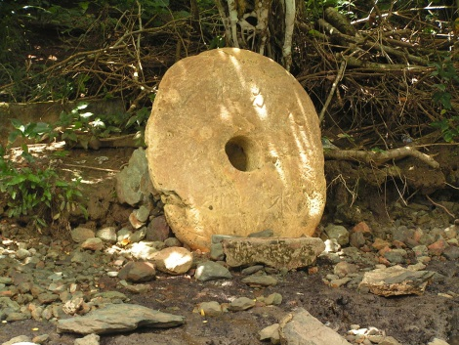
Image 5, © clipdealer
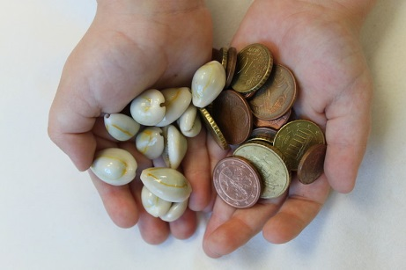
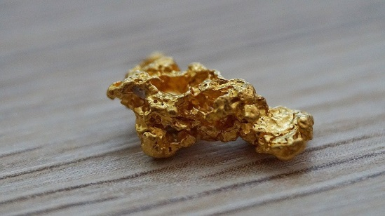
Image 2, © clipdealer
Image 1, © clipdealer

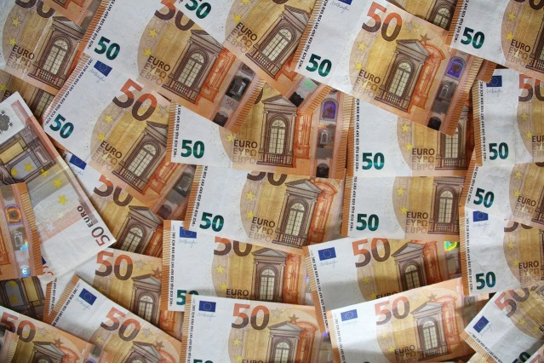
Image 6, © clipdealer
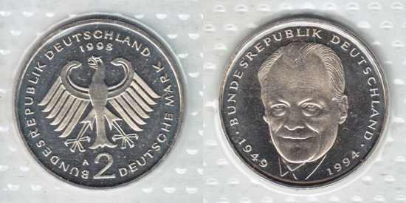
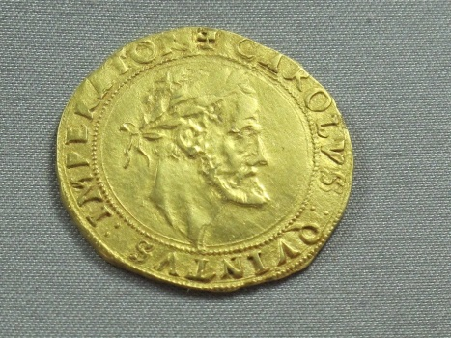
Image 4, © clipdealer
Image 3, © clipdealer

Lead-in 2

Share your impressions of this photograph with the others.

Venezuelan Refugees in Bogotá (Colombia) Selling Crafts Made of Worthless Venezuelan Banknotes

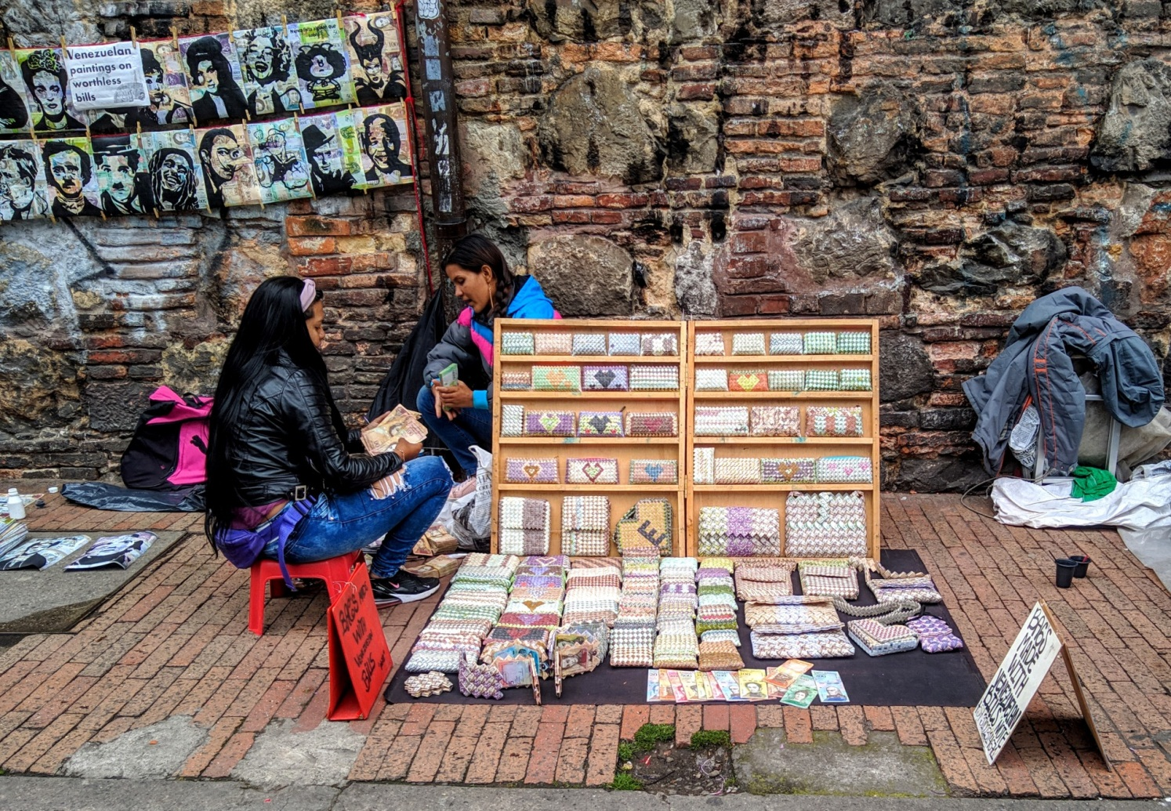
Photograph by Reg Natarajan, taken from:
https://en.wikipedia.org/wiki/File:Venezuelan_Refugees_in_Bogot%C3%A1_Selling_Crafts_Made_of_Worthless_Venezuelan_Cash_(49070277587).jpg under the CCA 2.0 Generic license: https://creativecommons.org/licenses/by/2.0/deed.en

Tasks
Task 1: Functions of money or why do we need money?
In small groups, discuss the essential functions of money (M 1), one function per group. Then write up your findings in the mind map the class is creating on the board. Take turns at presenting your group’s information to the class. Make notes on the information presented by the other groups so that you all have a complete mind map by the end of the task.

Task 2: Hyperinflation in Venezuela
Fishbowl discussion: talk about what damage hyperinflation did to the functions of money and to the people of Venezuela. To do this, follow the steps below:
- In your group watch your video clip and take notes on how hyperinflation impacted the functions of money and therefore people’s lives in Venezuela.

- Then get together in a fishbowl discussion with your whole class. Give a short report on the relevance of your video clip, including the functions of money. Enter the fishbowl whenever you feel you have something relevant to add or additional information from your video clip.

- Finally, discuss what you would do – especially financially – if a similar situation were to occur in Germany.

Word bank
cowry shell – Kaurimuschel
(legal) tender – (gesetzliches) Zahlungsmittel
commodity money – Warengeld

Medium of Exchange – Tauschmittel
Measure of Value – Wertmesser
Unit of Account – Rechenheinheit
Store of Value – Wertaufbewahrung
Transfer of Value – Wertübertragung

to barter – Tauschhandel treiben
exchange rate – Wechselkurs, Umrechnungskurs
commodity – Handelsgut, Ware
goods and services – Güter und Dienstleistungen
expenditure – Ausgaben
balance – Kontostand, Bilanz, Saldo
common denominator – gemeinsamer Nenner
to keep books (of account) – die (Geschäfts-)Bücher führen
term of a loan – Laufzeit eines Darlehens
loan –Kredit, Darlehen
credit / line of credit – Kreditlinie, die Möglichkeit einen Kredit zu bekommen
staple staple food – Grundnahrungsmittel

Material
M 1 Functions of Money or why do we need money?
There are numerous functions of money that can be identified and categorized individually. However, we’ll focus on five of the most important ones.
Group 1:
Without money it was necessary, for example, to barter chicken for wood, and then barter wood for milk, which is what you wanted to have in the first place. There was a lot of running around and wasting time trying to find the right people with the right kind of goods. Also, if someone wanted to trade a cow for a spoon, there was the problem that the cow was not easy to split, so what were people supposed to do?

Money serves as a general medium of exchange, which is most likely its most important function. Money can usually be used to be exchanged for any kind of good or service in a country. In addition to solving the problems mentioned above, money also makes it possible to specialize further. Let’s say someone contributes one small task in a chain of production but doesn’t actually produce any one thing him/herself, that person would not have anything to trade with. In our highly specialized and globalized economy, there is no other way of efficiently exchanging multiple goods and services than using money.

Group 2:
In a pre-money world people had to really know the value of everything. In other words, they would have had to know how much chicken is worth in comparison with wood, and what amount of wood would buy how much milk. Now add salt, wheat, sheep, shoes, firestones, weapons, horses, tables, fish and a thousand other goods to this calculation and you’d drown in a huge number of exchange rates. Money makes exchange(s) a lot simpler.

We use money to assign a value to all goods and services. In this way, it becomes simple to compare the prices or values of any commodity. This enables households to plan their expenditure and companies can keep track of their balance sheets.
Sometimes people speak about a separate function of money which is called a “Unit of Account”. It simply means that money makes it possible to do many kinds of calculation to compare the value of goods that come in different units such as milk (litres) or wood (fixed metres) etc. Money serves then as a common denominator which makes it possible to do modern accounting or measuring the gross domestic product (GDP) of a country. To sum up, we often think about the value of things in terms of money, compare these values to make our purchase decisions, and keep the books for economic transactions.

Group 3:
Part 1
Imagine you are very rich in a pre-money world. What would that even mean? Maybe you’d have a lot of cattle and a house. Maybe you’d have a lake which would provide a lot of fish every day. Rich people in our modern world have accumulated a lot of money or acquired a lot of real estate, for example. The problem with fish and the like is that if you wanted to put aside perishables to exchange them for something very valuable one day, nobody would want to have them once they’d gone off. It is well known that money doesn’t smell, and in comparison with a two-week-old dead fish, nothing could be closer to the truth. Fish is not a good store of value. In contrast, money does not decay in your pocket. You can save as much as you like and use it to store your wealth. It is entirely up to you at which point you turn money into the goods and services you want, which takes us to the next function of money.

Part 2
You can easily pocket your money and carry it to the next shop. (Try that with fish!) The shop owner will gladly accept your money because s/he knows that the value conserved in the money is now transferred to him/her/them. S/He, then, can use it to buy whatever s/he likes anytime. As long as everyone plays along, value can be transferred easily and quickly between people and companies. Your pocket money e.g., is a value transfer to you without any service/anything in return. (Alright, sometimes you have to do the dishes or mow the lawn.) Using modern technology e.g., electronic accounts, it is also possible to transfer value over great distances.
Or let’s say you lived in Bavaria and inherited a house on the Orkney Islands. Without money you’d have some value over there which ‘d be totally useless to you if you weren’t planning on moving. Today, you can sell the house, transfer its equivalent value to your account at home and be better-off right where you are.

M 2 Video clips
If you use youtube (Group 2 and 4), please note the terms of use.
Group 1: Surviving hyperinflation in Venezuela (Channel: France 24), watch from 0:35 to 3:51
https://mebis.link/fGAagi

Group 2: Venezuela sees resurgence of bartering as banks struggle to keep up with hyperinflation (Channel: ABC – Australian Broadcasting Corporation)
https://mebis.link/cPpa22
Group 3: Why Colombia has taken in 1 million Venezuelans (Channel: Vox), watch from the beginning to 3:39
https://mebis.link/BtBQSY

Group 4: IMF: Venezuela’s Inflation to hit 1,000,000 % (Channel: CNN)
https://mebis.link/w12P5z

Notes on the lesson plan
General information
This lesson prepares the students for further inquiry into financial investments. The lesson will give students the opportunity to familiarize themselves with the functions of money and the importance of price or money stability, and especially to explore the downsides of a loss of the functions of money. It will help to make sense of consecutive lessons on how and why to make private investments. They will first learn about the functions of money. The framework in the second part of the lesson is provided by the hyperinflationary situation in Venezuela.
The lesson starts either with the simple question of what the different images in the lead-in have in common or – if your students already know that and it would be too obvious - with an image that symbolizes the situation in Venezuela starting in 2016 and continuing up to March 2020 when the IMF expected the situation to become even worse in the course of the year. Venezuela has been suffering from hyperinflation since the Chavez administration started to finance huge social programs relying heavily on foreign debt. The Maduro administration continued to do so.
The current inflation rate is at a shocking 1.3 Million percent rendering the Bolivar (the Venezuelan currency) utterly useless which has had serious effects on the economic and social life in Venezuela. The background of Maduro cutting back the independence of the Central Bank and removing unwanted judges from the Supreme Court is a very important link to the field of politics, which is why students should be made aware of how a grasp of different sectors leads to a thorough understanding of a situation in its entirety.
The introductory photograph should be highly visible for the students, especially the writing on the poster saying, “Venezuelan paintings on worthless bills”. The task here has been specifically chosen to be a sharing of impressions, not a deep discussion about reasons and effects as students might either anticipate too much of the content to follow or share in half-truths without the necessary background knowledge which is to follow.
In a second step the students read texts about the functions of money and create a mind map on the board from them.
Finally, the students are asked to watch some video clips and to join in the fishbowl discussion about how the loss of the functions of money has impacted the life of Venezuelans. With a view to the topic of financial investments, the students can then be asked what they would do with their money if they expected the situation in their home country to deteriorate equally badly. The lesson could end with this discussion. At any rate, at some point it should be made clear that an independent central bank is of utmost importance to the well-being of a people/nation.
By the way, Geography also deals with development and challenges in South America (Geo 10 Lernbereich 7).

Task 1
A credit line is an amount of money/the limit to the amount of money you can access through a bank or your credit card when you need it.
Make sure you are knowledgeable about the difference between the terms “credit” and “loan” for students might ask. A loan is a fixed sum of money someone borrows e.g., from a bank. A credit as in “line of credit” is what someone can take out e.g., from a bank or the sum someone can e.g., spend on a credit card. A line of credit is flexible; a loan is a fixed sum of money paid to the debtor’s account.
The video clips are of the ongoing crisis in Venezuela over several years. Therefore, the prices and inflation rates mentioned vary. If students ask, then you can tell them that it is not really important which inflation rate or price is valid at a particular time but rather to form a comprehensive picture of continuously soaring prices.

Task 2
For this task your students need access to youtube videostreaming. Please note the terms of use.

Possible findings
Lead-in 1
All of the depicted items were or are (legal) tender at a specific time.

Lead-in 2
Any number of student’s answers, e.g.:
- women making handbags
- crafting
- they are making things out of worthless banknotes
- … because they cannot buy anything with this money anyway
- inflation
- …

Task 1
Mind map which contains the most important information on M 1 e.g.
Medium of Exchange
- Can be exchanged for any goods or services
- Replaces complicated bartering
- Facilitates specialization
Measure of Value
- Replaces numerous exchange rates
- Common denominator for value
- Helps to compare values
- “Unit of account”, helps to keep track of economic transactions

Functions of money

Store of Value and Transfer of Value
- Can store value permanently
- Easy to transport
- Value can be easily transferred even without any return service
- transfer over long distances

Task 2
Video clip 1: taxi driver who cannot afford a spare part as auto/car parts are often imported goods; with hyperinflation they are unaffordable for Venezuelans; he loses a lot of time looking for a spare part and trying to repair the old part, very inefficient, in the end he’ll still have to buy a new part
Video clip 2: people start paying in fish in exchange for flour, rice, cooking oil and medication because of hyperinflation and a lack of notes; people would need “enormous piles of notes” to pay for even the cheap goods or services; even haircuts are paid by bartering; 25,000% inflation (beginning of 2018)
Video clip 3: refugee crisis at the Venezuelan-Columbian border due to the situation in Venezuela, one million refugees by 2018, purses and sculptures made from notes, inflation rate rising to one million %, women selling their hair, a hotdog costs one month’s salary, 87% household poverty, political reasons; people cannot afford medical treatment for their children
Video clip 4: inflation rate to rise to one million % in 2018, GDP dropping sharply, cost of food and medicine soaring, especially hard for pensioners and the like;
Fish being bartered (this is also shown in the second clip); engineers make car parts from garbage; central bank cannot keep printing notes, government cannot afford the paper for them; four million people have left since 2016; plan: (has already been put into action) drop five digits from the currency, will not help.

