Global Interdependencies in Everyday Life

(Example: Jeans)
Stand: 14.07.2021
Jahrgangsstufen | 8
Fach/Fächer | Geographie
Übergreifende Bildungs- und Erziehungsziele | Ökonomische Verbraucherbildung  Bildung für Nachhaltige Entwicklung  Politische Bildung
Zeitrahmen | 2 - 4 Stunden
Benötigtes Material | Arbeitsblätter, vgl. unten

Kompetenzerwartungen
Geo 8, LB 4, KE 1,2,3
Die Schülerinnen und Schüler ...
- nutzen ihr topographisches Orientierungswissen, um die behandelten Fragen der Globalisierung (z. B. die einzelnen Standorte einer Produktionskette) räumlich einzuordnen.

- stellen wirtschaftliche Verflechtungen anhand der Produktion von einem Konsumgut dar (z. B. Jeans).

- beschreiben und bewerten deren Produktionskette unter ökonomischen, ökologischen und sozialen Gesichtspunkten.

Aufgabe
carbon dioxide economically disadvantaged
manufacture climate change available
wages environment (2) industrialized
economy insurance
1. Vocabulary
In the box you can find some words or phrases
you will need in order to understand the following
video that explains globalization. Fill in the gaps.

Germany, Switzerland or Japan are _____________________________________ countries. Here the ___________________________________ (>> the system of trade and industry) is at a high level. Companies _____________________________ (>> produce) a lot of different products. The goods produced are ________________________________ in many countries.
In contrast to those countries Nigeria, Eritrea or Syria are poor countries. Such countries are called ___________________________________________ countries. People are poorly paid, the _______________________________ are low. Most people do not have health or social ____________________________. Another problem is that most companies do not care about the _______________________________________ which means that rivers are polluted and the emissions of _________________________________________ increase. Of course, this leads to ___________________________________. Don’t forget there is no second earth, so we have to protect our _____________________________ (>> nature and all the animals).
2. Traveling around the globe.
Read the text “Travel blog of a pair of jeans” and complete the table.
Country | Process - What happened here?
1. | picking cotton, use of ...
2.
3.
4.
5.
6.
7. | bargain bin in department store, price 14,95 €
Label all the different countries mentioned in the text on a world map. You can use arrows, post-its and so on.
Alternative: Make a short video (note: there should be a map of the world in the background) which shows and explains the most important steps of the production of jeans.
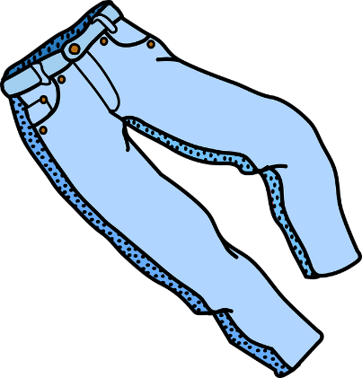
Travel blog of a pair of jeans

A pair of jeans tells its story:
I would like to introduce myself: I’m a pair of jeans! And I’m really proud because I’m worn by men and women of all ages. In
addition, I just cost € 14,95. I see, you are amazed. And you
can’t imagine what countries I have traveled to ...
Abb. 1
I was born in the cotton fields of the USA, where workers pick the cotton that will be used to create denim material. There the German immigrant Levi Strauss invented jeans as very solid workwear for gold diggers in the 19th century. But back to the present! On our large cotton plantation the workers used pesticides to increase the yield. That really damages their health. After being picked, I was shipped to Turkey where I was turned into yarn. Then I traveled to Taiwan. I woke up in a dark and noisy weaving mill. Now that I was a fabric I was allowed to go to Tunisia, where I had to take a bath in acid. They told me that it would help me to absorb the color, which came from Poland, by the way. Of course, the workers breathe in the polluted air which might cause cancer or other diseases. But they don’t protest although their wages are really low. Oh, I love telling you about Bangladesh. I owe my trendy cut to the quick soft hands of the women working in large halls without emergency exits there. Yeah, I was so glad that the zippers and the buttons arrived on time from Italy. You know I really love my looks but bad things happened in China when I was about to get the fashionable “used -look“. Children, yes children work in Xintang, the jeans capital of the world. The workers’ lungs are damaged after just a few years. In addition, fabric printing and dyeing involves heavy metals such as cadmium, lead and mercury – not stuff that you want to be getting near your bare skin! But these people touch them every day. Can you imagine what is happening to their skin? Later on I continued my journey to Germany.
Hello my dear costumers, here I am. 8000 liters of water and 50000 air miles were needed for my production. And now I find myself in a bargain bin in a department store among
hundreds of other jeans. You can buy me for just 14,95 Euros.

3. What do you think about the production of jeans?
1 = perfect
2 = good
3 = questionable
4 = bad
Complete the following sentences.

From an economic point of view I would say the production of jeans
gets 1-2-3-4, because...

Referring to the protection of the environment I think the production of jeans is….

From a social point of view I think the production of jeans is…

Show your opinion in the graph below. Discuss similarities and differences with your classmates.
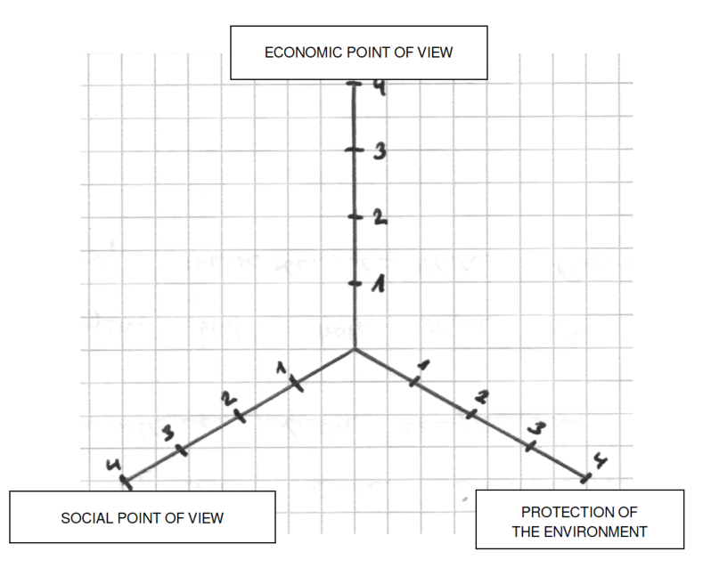

Abb. 2

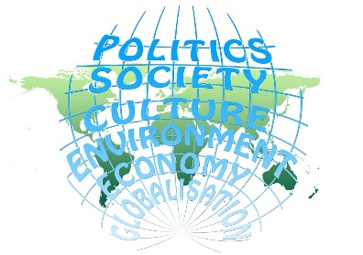
4. Basic Knowledge of Globalization

Watch the video twice and develop a memo image.
(1/2- or 1- page DIN A4).
https://lernplattform.mebis.bayern.de/course/view.php?id=1162786&section=0
Schlüssel zur Selbsteinschreibung: BiliGeo8
Abb. 3

The following structure might help you:
A short definition of the term globalization
-
advantages of globalization | disadvantages of globalization

Hinweise zum Unterricht
1) Die Schülerinnen und Schüler erläutern und beurteilen die internationale Arbeitsteilung am Beispiel der Jeans.
2) Der Erklärfilm von explainity® kann im Plenum vorgeführt werden. Denkbar wäre aber auch die individuelle Analyse als Live-Stream (Smartphone, PC...) in Zweierteams oder Kleingruppen.
Bei leistungsschwächeren Gruppen wäre es sinnvoll den Erklärfilm in Etappen zu zeigen und die wichtigsten Inhalte in eigenen Worten zusammen zu fassen bevor die Schülerinnen und Schüler ein Merkbild erstellen.
3) Am Ende der Unterrichtseinheit wäre eine Diskussion über das eigene Konsumverhalten denkbar.

Quellen- und Literaturangaben
Abbildung 1: Jeans
Titel: „Blickpunkt: Ich gifte Sie an! Ein T-Shirt plaudert aus dem Nähkästchen“
Quelle: https://pixabay.com/de/kleidung-schlauch-hosen-1294974/
Lizenziert nach: CC0 Public Domain
Abbildung 2 / Grafik: ISB
Abbildung 3: Globalization
Quelle: https://pixabay.com/de/globalisierung-politik-gesellschaft-452692/
Lizenziert nach: CC0 Public Domain
Zugriffsdatum: 14.07.2016
Videolink: Globalization
Titel: Globalization explained (explainity® Erklärvideo)
Autor: explainity GmbH, veröffentlicht im Rahmen des nicht-kommerziellen explainity education project
Link: https://lernplattform.mebis.bayern.de/course/view.php?id=1162786&section=0
Schlüssel zur Selbsteinschreibung: BiliGeo8
Lizenziert nach: YouTube-Lizenz, mit freundlicher Genehmigung durch explainity®
Zugriffsdatum: 10.10.2020
Text: „Für 14,95 um die Welt - Weltreise einer Jeans“: Eigenproduktion, übersetzt am ISB

Lösungsmuster
carbon dioxide economically disadvantaged
manufacture climate change available
wages environment (2) industrialized
economy insurance
1. Vocabulary
In the box you can find some words or phrases
you will need in order to understand the following
video that explains globalization. Fill in the gaps.

Germany, Switzerland or Japan are __________industrialized_______ countries. Here the _______economy_______________ (>> the system of trade and industry) is at a high level. Companies _________manufacture ___________ (>> produce) a lot of different products. The goods produced are _______available____________ in many countries.
In contrast to those countries Nigeria, Eritrea or Syria are poor countries. Such countries are called ______economically disadvantaged__________ countries. People are poorly paid, the ___________wages__________ are low. Most people do not have health or social _________insurance________. Another problem is that most companies do not care about the __________environment___________ which means that rivers are polluted and the
emissions of ____________carbon dioxide______________ increase. Of course, this leads to _________climate change_____________. Don’t forget there is no second earth, so we have to protect our ____________environment____________ (>> nature and all the animals).
2. Traveling around the globe.
Read the text “Travel blog of a pair of jeans” and complete the table.
Country | Process - What happened here?
1. USA | picking cotton, use of ... pesticides
2. Turkey | cotton turned into yarn
3. Taiwan | weaving mill yarn turned into fabric
4. Tunisia | bath in acid
5. Bangladesh | get trendy cut
6. China | get “used – look“
7. Germany | bargain bin in department store, price 14,95 €
Label all the different countries mentioned in the text on a world map. You can use arrows, post-its and so on.
Alternative: Make a short video (note: there should be a map of the world in the background), which shows and explains the most important steps of the production of jeans.

3. What do you think about the production of jeans?
1 = perfect
2 = good
3 = questionable
4 = bad
Complete the following sentences.

From an economic point of view I would say the production of jeans
gets 1-2-3-4, because... – freie Schüleräußerung –

Referring to the protection of the environment I think the production of jeans is….
– freie Schüleräußerung –
From a social point of view I think the production of jeans is…
– freie Schüleräußerung –
Show your opinion in the graph below. Discuss similarities and differences with your classmates.
– freie Schüleräußerung –

Abb. 2

4. Basic Knowledge of Globalization

Watch the video twice and develop a memo image.
(1/2- or 1- page DIN A4).
https://www.youtube.com/watch?v=JJ0nFD19eT8

Abb. 3

The following structure might help you:
A short definition of the term globalization
- world-wide coming together of countries and nations
advantages of globalization | disadvantages of globalization
people and countries can exchange goods and information quickly and in a less complicated way | people in industrialized countries lose jobs
- more affordable products are available  for more people | people in developing countries work for very little money  - remain poor
- job opportunities for locals in economically disadvantaged countries | people in developing countries do not have  sufficient insurance cover
ecological problems
- climate change
 | environmental standards are ignored

yarn = Garn
fabric = Stoff
acid = Säure
zipper = Reißverschluss
button = Knopf
to dye = färben
lead = Blei
mercury = Quecksilber

