Analysing a picture
Look at the picture you have chosen carefully. Prepare a short presentation of it. Then follow the instructions/answer the questions below.
Steps | Chunks
Describe the picture
- Who/What does it mainly show?  - What can you see?  - What are the people doing?  - What do the people look like?  - What’s happening?  - What details/symbols are there?  - Where are the symbols, things, people etc.?  - … | The picture is mainly about …  There is/are …  People are …  The colours are …  Some objects are …  I guess the … shows that …  on the right / on the left / in the middle / at the top / at the  bottom …
- What do you see?
_____________________________
_____________________________
_____________________________
_____________________________
_____________________________
_____________________________
_____________________________
_____________________________
_____________________________
_____________________________________________________________________________________________________________________________________________________________________________________________________________________________________________________________________________
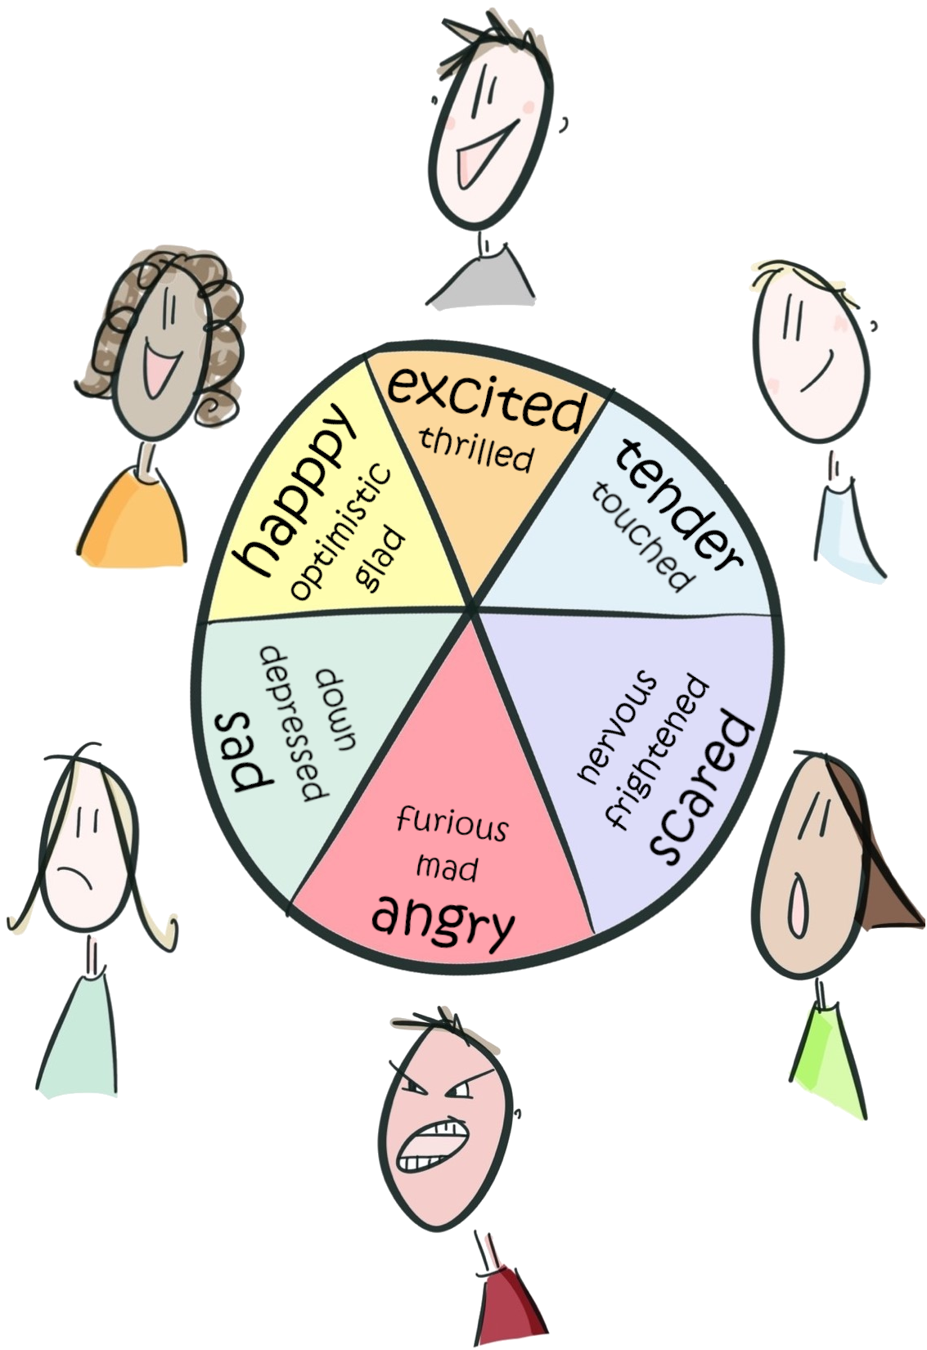Emotions
chunks
The picture makes me feel …
When I look at the image, I feel … because
- What do you feel?
__________________________________________
__________________________________________
__________________________________________
__________________________________________
__________________________________________
__________________________________________
__________________________________________
- What would you like to know about the picture?
__________________________________________
__________________________________________
__________________________________________
__________________________________________
__________________________________________

