BRAINSTORMING / PLACEMAT
Our three questions
- ________________________________________________________________________________________________________________
- ________________________________________________________________________________________________________________
- ________________________________________________________________________________________________________________
- THINK
Look at the picture carefully, and then finish the sentences given. Next, write down questions you have (what would you like to know about the picture?).
- PAIR
Present your ideas to each other and agree on the three most important questions you have. Write them down in the box on the right.
- SHARE
Present your ideas to the rest of the class.
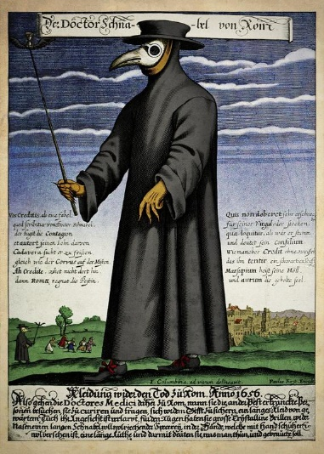
M1
I see __________
___________________
______________________
__________________________
______________________________
I hear ____________________________
____________________________________
I feel ___________________________________
because ____________________________________
My questions: ____________________________________
___________________________________________________
________________________________________________________
____________________________________________________________
I see __________
___________________
______________________
__________________________
______________________________
I hear ____________________________
____________________________________
I feel ___________________________________
because ____________________________________
My questions: ____________________________________
___________________________________________________
________________________________________________________
____________________________________________________________
I see _______________________________________________
___________________________________________________________________
I hear ______________________________________________________________________________
I feel ________________________________________because________________________________________________
My questions: ______________________________________________________________________________________________________
I see _______________________________________________
___________________________________________________________________
I hear ______________________________________________________________________________
I feel ________________________________________because________________________________________________
My questions: ______________________________________________________________________________________________________

