Causes of Climate Change
Stand: März 2024
Jahrgangsstufe | 10, Lernbereich 10.4: Klima im Wandel
Fach | Geographie
Übergreifende Bildungs- und Erziehungsziele | Alltagskompetenz und Lebensökonomie, Werteerziehung, Bildung für Nachhaltige Entwicklung
Zeitrahmen | 4 Unterrichtsstunden
Benötigtes Material | Internetzugang, Diercke Weltatlas (2015)

Kompetenzerwartungen
Die Schülerinnen und Schüler ...
- erschließen die Ursachen für den zunehmenden anthropogenen Treibhauseffekt unter Berücksichtigung wissenschaftlicher Erkenntnisse.
- stellen unterschiedliche Positionen und Meinungen zum Klimawandel dar und hinterfragen diese kritisch.

Task
Prepare for a discussion at your school about the climate crisis by working on the following tasks:
Most discussions and political decisions regarding global warming are based on data provided by the Intergovernmental Panel on Climate Change (IPCC). The IPCC is the United Nations body for assessing the science related to climate change.
- Read M 1 and give reasons why the IPCC is a trustworthy source of scientific data.
- Draw an easy-to-understand sketch showing the natural greenhouse effect using M 2 and M 3.
- The composition of the Earth’s atmosphere is changing.
  - Analyse the concentrations of greenhouse gases (GHGs) in the atmosphere as shown in M 4.
  - Explain the findings of your analysis and their consequences for the atmosphere. Find proof for your hypothesis on the internet. Choose your sources carefully.
- To be able to discuss effective means of climate action, it is essential to understand the causes of global warming.
  - Use M 5 and M 6 to explain why it is important to reduce all greenhouses gases.
  - Fill in the missing information in M 7 to compare global carbon dioxide emissions. You can use “Diercke Weltatlas” (2015), p. 264, map 2.
  - “Every individual contributes to global warming!” Comment on this statement and prove your point by referring to M 5 and M 8.
- Prepare your role (M 9) and then in your discussion agree on three concrete actions your school could take in order to reduce GHG emissions.

Word bank
alternative forms of energy – alternative Energieformen
carbon cycle – Kohlenstoffkreislauf
combustion – Verbrennung
crude oil – Erdöl, Rohöl
deforestation (no pl) – Abholzung, Entwaldung
degradation – Verschlechterung, Schädigung
electricity generation – Stromerzeugung
emission(s) – Emission, Ausstoß
energy saving – energiesparend
environmental protection laws – Umweltschutzgesetze
fuel-saving – treibstoffsparend
greenhouse gas – Treibhausgas
longwave radiation – langwellige Strahlung
Manure (organic matter) – Dünger
natural gas – Erdgas
radiation – Radiation, Strahlung
species (pl) – Spezies, Art
(synthetic) fertilizer – Kunstdünger
thermal radiation – Wärmestrahlung
to decompose – zersetzen
to emit – aussoßen, emittieren
water vapour – Wasserdampf

Material
M 1 The Intergovernmental Panel on Climate Change
Created in 1988 by the World Meteorological Organization (WMO) and the United Nations Environment Programme (UNEP), the objective of the IPCC is to provide governments at all levels with scientific information that they can use to develop climate policies. IPCC reports are also a key input into international climate change negotiations.
The IPCC is an organization of governments that are members of the United Nations or WMO. The IPCC currently has 195 members. Thousands of people from all over the world contribute to the work of the IPCC. For the assessment reports, experts volunteer their time as IPCC authors to assess the thousands of scientific papers published each year to provide a comprehensive summary of what is known about the drivers of climate change, its impacts and future risks, and how adaptation and mitigation can reduce those risks.
An open and transparent review by experts and governments around the world is an essential part of the IPCC process to ensure an objective and complete assessment and to reflect a diverse range of views and expertise. Through its assessments, the IPCC identifies the strength of scientific agreement in different areas and indicates where further research is needed. The IPCC does not conduct its own research.
Source: https://www.ipcc.ch/about/ [03/28/2024].

M 2 Estimate of the Earth’s annual and global mean energy balance in watt per square metre (Wm⁻²)
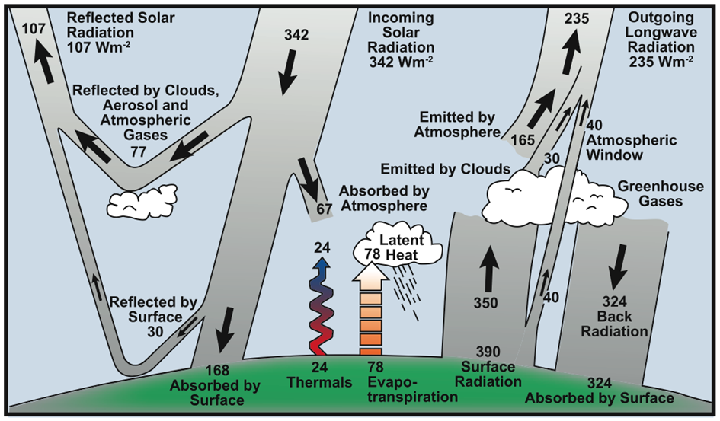
Source: https://archive.ipcc.ch/publications_and_data/ar4/wg1/en/faq-1-1.html [03/28/2024],
Kiehl and Trenberth (1997).

M 3 The Natural Greenhouse Effect
The sun powers the Earth’s climate, radiating energy at very short wavelengths, predominately in the visible or near-visible (e.g., ultraviolet) part of the spectrum. Roughly one-third of the solar energy that reaches the top of the Earth’s atmosphere is reflected directly back to space. The remaining two-thirds is absorbed by the surface and, to a lesser extent, by the atmosphere. To balance the absorbed incoming energy, the Earth must, on average, radiate the same amount of energy back to space. Being much colder than the sun, the Earth radiates at much longer wavelengths, primarily in the infrared part of the spectrum. Much of this thermal radiation emitted by the continents and ocean is absorbed by the atmosphere, including clouds, and re-radiated back to the Earth.
The global mean surface temperature is about 14°C. The reason the Earth’s surface is so warm is the presence of greenhouse gases, which act as a partial blanket for the longwave radiation coming from the surface. This blanketing is known as the natural greenhouse effect. The glass walls in a greenhouse reduce airflow and increase the temperature of the air inside. Analogously, but through a different physical process, the Earth’s greenhouse effect warms the surface of the planet. The two most abundant gases in the atmosphere, nitrogen (comprising 78% of the dry atmosphere) and oxygen (comprising 21%), exert almost no greenhouse effect. Instead, the greenhouse effect comes from molecules that are more complex and much less common. Water vapour is the most important greenhouse gas, and carbon dioxide the second-most important. Methane, nitrous oxide, ozone and several other gases present in the atmosphere in small amounts also contribute to the greenhouse effect.
Without the natural greenhouse effect, the average temperature at the Earth’s surface would be below the freezing point of water. Thus, Earth’s natural greenhouse effect makes life as we know it possible.
M 4 Concentration of Greenhouse Gases
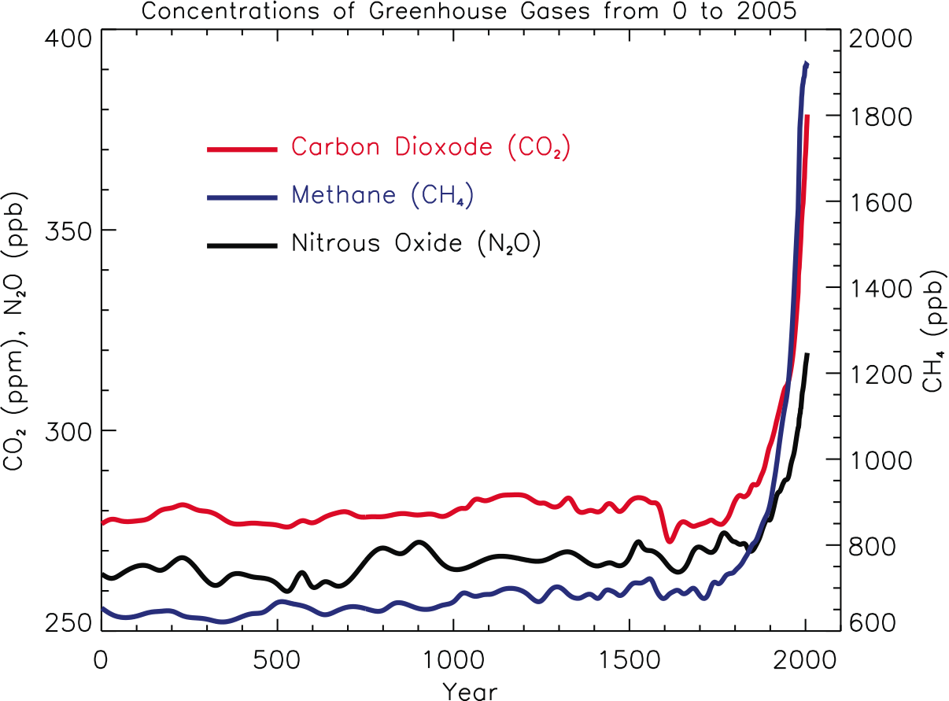
Atmospheric concentrations of important long-lived greenhouse gases over the last 2,000 years. Concentration units are parts per million (ppm) or parts per billion (ppb), indicating the number of molecules of the greenhouse gas per million or billion air molecules, respectively, in an atmospheric sample.
Source: https://archive.ipcc.ch/publications_and_data/ar4/wg1/en/faq-2-1-figure-1.html [03/28/2024].

M 5 Characteristics of greenhouse gases (GHGs)
GHGs warm the Earth by absorbing energy and slowing the rate at which the energy escapes to space. Different GHGs can have different effects on the warming of the atmosphere. Two key ways in which these gases differ from each other are their Global Warming Potential (GWP), and how long they remain in the atmosphere (lifetime). The GWP shows how much heat a greenhouse gas traps in the atmosphere over 20 or 100 years relative to carbon dioxide (GWP of CO₂ = 1). The table shows the most effective GHGs: water vapour is an additional and very effective GHG.
GHG | LIFE TIME IN YEARS | GWP | MAIN SOURCES | NATURAL SOURCES
carbon dioxide (CO₂) | up to 1,000 years, unless absorbed in global carbon cycle | 1 | - combustion of fossil fuels such as gasoline and diesel to transport people and goods (highway vehicles, air travel, marine transportation and rail)  - combustion of fossil fuels to generate electricity, for heating  - production and consumption of mineral products such as cement, the production of metals such as iron and steel, production of chemicals  - deforestation releases CO₂ and reduces its uptake by plants | CO₂ is constantly being exchanged among the atmosphere, ocean, and land surface as it is both produced and absorbed by many microorganisms, plants, and animals (= natural carbon cycle).
Methane (CH₄) | 12 | 25 | - production, storage and distribution of natural gas and crude oil  - coal mining  - domestic livestock such as cattle or swine produce CH₄ as part of their normal digestive process  - landfills as waste decomposes | natural processes that occur, for example, in wetlands where  bacteria decompose organic materials
nitrous oxide  (N₂O) | 114 | 300 | - in agriculture: synthetic and organic fertilizers, the management of manure  - byproduct of the production of chemicals such as nitric acid used to make fertilizer  - byproduct of the production of adipic acid, which is used to make fibres, like nylon, and other synthetic products  - treatment of domestic wastewater | many sources associated with the nitrogen cycle, which is the natural circulation of nitrogen among the atmosphere, plants, animals, and microorganisms that live in soil and water
fluorinated gases  (SF₆ for example) | 3,200 | 22,800 | - mainly industry/ manufacturing:  magnesium processing, semiconductor manufacturing, coolant, … | only from human-related activities

Sources: https://www.epa.gov/ghgemissions/overview-greenhouse-gases [03/28/2024]]; https://www.umweltbundesamt.de/sites/default/files/medien/2503/dokumente/treibhauspotentiale_ausgewaehlter_verbindungen_und_deren_gemische.pdf [02/20/2020].

M 6 Greenhouse Gas Emissions in Germany by Substance

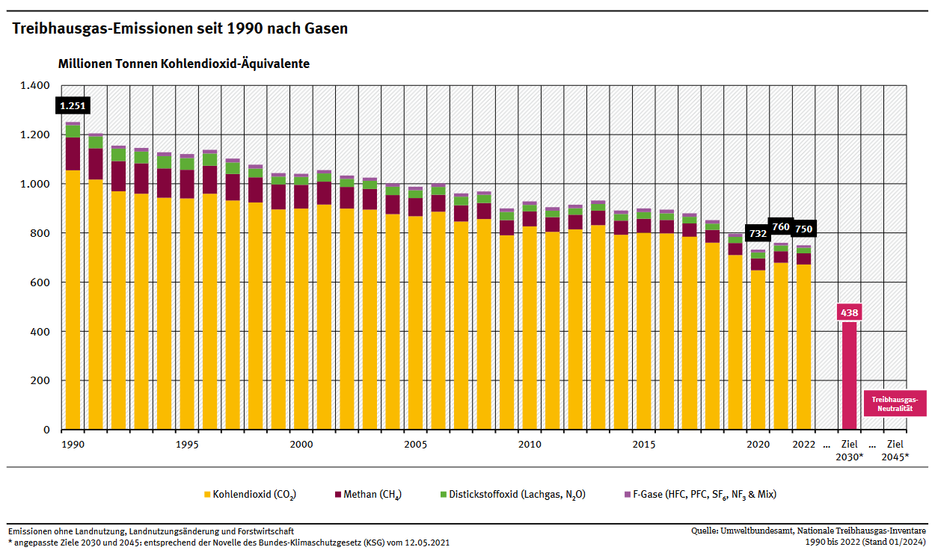

Source: https://www.umweltbundesamt.de/sites/default/files/medien/384/bilder/dateien/2_abb_thg-emissionen-seit-1990-nach-gasen_2024-01-23.pdf [03/28/2024].

https://mebis.link/p59taz

M 7 Carbon Dioxide Emissions – Working with a Map

In 2012 the USA emitted more than ____________________________ of carbon dioxide, which is ____________ tons per inhabitant. In comparison, Germany emitted ________________________ per inhabitant in 2012, which is a total of _________________________________ of carbon dioxide. In Europe, ________________________ is the country with the highest carbon dioxide emissions in total. According to the map, the “top 5” carbon dioxide emitters worldwide are: _____________________________________________________________________________. Most countries in Africa have carbon dioxide emissions of ______________________________ ton per inhabitant (with the exception of _________________________ and _____________________). Likewise, South America has carbon dioxide emissions of _______________________ tons per inhabitant (with the exception of ______________________).
In 2012 the generation of electricity made up _____________________ of GHG emissions. In contrast to _________________________________ kw/year in 2012 of electricity generation in Africa, the USA generated ________________________________ kw/year. The highest increase of electricity generation from _______________________________ kw/year in 1995 to ______________________________ kw/year in 2012 was in South and East Asia. This is an increase of _________________________________ kw/year, which is more than the total amount of electricity generation in 2012 in all other regions of the world. _______________________ are the predominant sources of energy for electricity generation, except for _________________________________ (region) where __________________________ produced ___________________________ of the electricity in 2012. In Europe the percentage of _________________________________ increased between 1995 and 2012. __________________________, however, are still the largest source of energy in Europe.

M 8 Greenhouse Gas Emissions in Germany by Source

https://mebis.link/pBov16

Source:
https://www.umweltbundesamt.de/diagramm/jaehrliche-treibhausgas-emissionen-in-deutschland-0 [03/28/2024].

M 9 Role Cards

- Prepare your role and think of three steps you are willing to take for climate action!

- Discuss the quote from Friday for Future and agree on three steps of climate protection at your school.

“Confusion, not the climate, is our worst enemy right now. […]
Understand that climate change is not an ‘environmental’ problem.
Climate change is a ‘people’ problem.”
Source: https://climatesafety.info/youth-decarboniser-revolution/ [03/28/2024].

moderator | engineer at a German  automobile company
- How do I open the discussion?  - Which aspects should be discussed?  - Which questions to the participants might be helpful/ interesting?  - How could an agreement be reached? Which climate actions might be feasible/ unrealistic for our school? | - How do I contribute to global climate change?  - How could I protect the climate? What am I not willing/able to do?  - What do I expect others to do?

student,  climate activist | parent,  commuter
- How do I contribute to global climate change?  - How could I protect the climate? What am I not willing/able to do?  - What do I expect others to do? | - How do I contribute to global climate change?  - How could I protect the climate? What am I not willing/able to do?  - What do I expect others to do?
principal | journalist
- How do I contribute to global climate change?  - How could I protect the climate? What am I not willing/able to do?  - What do I expect others to do? | A journalist who criticizes the creation of an atmosphere of fear and disapproves of bans on everything. Even the idea of man-made climate change is exaggerated in his view.

Hinweise zum Unterricht
Es bietet sich an, für die Entwicklung der Leitfrage aktuelle Ereignisse zum Thema Klimawandel mithilfe moderner Medien zu visualisieren. Als besonders zielführend bieten sich kurze Beiträge an, die unterschiedliche Meinungen zum Thema anthropogener Klimawandel darstellen (z. B. Interviews von Klimaskeptikern vs. Aussagen von Klimaaktivisten).
Im Rahmen der Lernaufgabe beschäftigen sich die Schülerinnen und Schüler mit den Ursachen des anthropogenen Klimawandels und bereiten sich dadurch auf die Durchführung einer Diskussion vor. Die vielfältigen Folgen des Klimawandels werden ausführlich in den Folgestunden thematisiert.

Possible findings

- Most discussions and political decisions regarding global warming are based on data provided by the IPCC. Read M 1 and give reasons why the IPCC is a trustworthy source of scientific data.
- the Intergovernmental Panel on Climate Change (IPCC) is the United Nations body for assessing the science related to climate change
- consists of large number of scientists of universities/ institutes from all over the world
- scientists` research is independent and voluntary
- inter-disciplinary and continuous research
- no political, economic interests

- Draw an easy-to-understand sketch showing the natural greenhouse effect using M 2 and M 3.
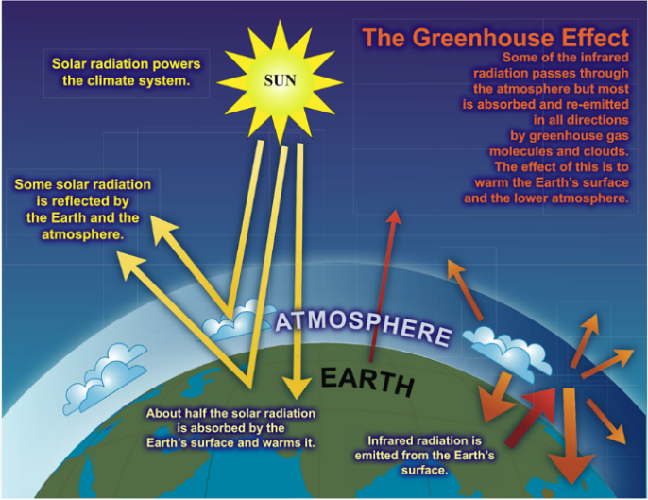
Source: https://archive.ipcc.ch/publications_and_data/ar4/wg1/en/faq-1-3.html [03/28/2024].
Anstelle eines Bildes kann hier auch die Erstellung eines kurzen Erklärvideos gefordert werden. Beispiele für Erklärvideos finden sich auf mebis (z. B. Klimawandel einfach erklärt von explainity®).
- The composition of the Earth’s atmosphere is changing.
  - Analyse the concentrations of greenhouse gases (GHGs) in the atmosphere as shown in M 4.
All gases accumulate in the atmosphere over time, causing concentrations to increase. Significant increases in all of these gases have occurred in the industrial era starting in 1750.
  - Explain the findings of your analysis and their consequences for the atmosphere. Find proof for your hypothesis on the internet. Choose your sources carefully.
An increase in GHGs leads to greater energy absorption and thus higher temperatures (global warming/ anthropogenic impact on greenhouse effect). The complex climate system is affected in various ways, which in turn has effects on other systems of our planet (hydrosphere, biosphere, pedosphere, cryosphere). Evidence from the internet, for example: https://archive.ipcc.ch/publications_and_data/ar4/wg1/en/tssts-3-1-1.html [03/28/2024].

- To be able to discuss effective means of climate action, it is essential to understand the causes of global warming.
a. Use M 5 and M 6 to explain why it is important to reduce all greenhouses gases.
- highest emission of carbon dioxide with very long lifetime
- however: extremely high GWP + lifetime of gases like methane or F-gases; reduction of only one GHG would not be effective enough
- methane: 16% of global GHG emissions, second largest after carbon dioxide of all GHGs
- no natural sources of F-gases, severe impact on climate
- various sources of GHGs call for a wide range of measurements
- The role of water vapour as an abundant GHG and the effect of water vapour feedback should be added here (reference to M 3).

b. Fill in the missing information in M 7 to compare global carbon dioxide emissions. You can use “Diercke Weltatlas” (2015), p. 264, map 2.
In 2012 the USA emitted more than 1000 million tons of carbon dioxide, which is over 15 tons per inhabitant. In comparison, Germany emitted 5-10 tons per inhabitant in 2012, which is a total of 500-1000 million tons of carbon dioxide. In Europe, Germany is the country with the highest carbon dioxide emissions in total. According to the map, the “top 5” carbon dioxide emitters worldwide are: the USA, Russia, China, Japan and India. Most countries in Africa have carbon dioxide emissions of under 1 ton per inhabitant (with the exception of South Africa/Libya). Likewise, South America has carbon dioxide emissions of 1-5 tons per inhabitant (with the exception of Venezuela). In 2012 the generation of electricity made up 29% of GHG emissions. In contrast to 655 billion kw/year in 2012 of electricity generation in Africa, the USA generated 4,944 billion kw/year. The highest increase of electricity generation from 2,970 billion kw/year in 1995 to 7,991 billion kw/year in 2012 was in South and East Asia. This is an increase of 5,021 billion kw/year, which is more than the total amount of electricity generation in 2012 in all other regions of the world. Fossil fuels are the predominant source of energy for electricity generation, except in South America where hydroelectric power stations produced more than half of the electricity. In Europe the percentage of renewable energy sources increased between 1995 and 2012. Fossil fuels, however, are still the largest source of energy in Europe.
c. “Every individual contributes to global warming!” Comment on this statement and prove your point by referring to M 5 and M 8.
For example:
- food/ eating habits: increase in meat consumption
- livestock farming/ fertilizer production/ food production contribute to CH4 and CO2 emissions
- combustion of fossil fuels:
- transport: cars/ planes, heating at home
- not “every” individual contributes to the same extent: stark differences of CO2 emissions worldwide, only small contribution from third world countries

- Prepare your role (M 9) and then in your discussion agree on three concrete actions your school could take in order to reduce GHG emissions.
The discussion aims at agreement on three concrete actions to protect the climate. If more information about concrete ways of omit GHG emissions is needed, students could browse the following websites:
https://climate-pact.europa.eu/index_en
https://ec.europa.eu/clima/sites/youth/node_en
https://www.bpb.de/gesellschaft/umwelt/klimawandel/38565/massnahmen
https://www.umweltbundesamt.de/themen/verkehr-laerm/emissionsdaten#emissionen-im-personenverkehr-grafik

