Tourism in Jamaica
Stand: März 2024
Jahrgangsstufe | 10, Lernbereich 10.7: Herausforderungen der Entwicklung in tropischen Räumen – Mittel- und Südamerika, Karibik
Fach | Geographie
Übergreifende Bildungs- und Erziehungsziele | Alltagskompetenz und Lebensökonomie, Werteerziehung, Bildung für nachhaltige Entwicklung
Zeitrahmen | 2 Unterrichtsstunden
Benötigtes Material | Internetzugang

Kompetenzerwartungen
Die Schülerinnen und Schüler ...
- erörtern Folgen des internationalen Massentourismus und leiten daraus Handlungsrichtlinien für eigene Reisen ab.

Task
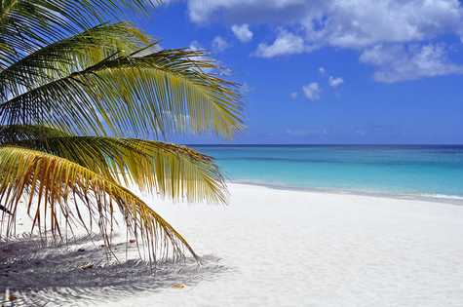
© clipdealer

A holiday in the Caribbean has always been your family’s dream. You, however, are doubtful whether this destination is an appropriate choice.
Your family is very interested in Jamaica and has done some research to help them make a decision. Present the findings (Material A or Material B) and discuss the pros and cons. Then decide whether or not you’ll make your dream come true.

Word bank
competition – Konkurrenz
condominium – Wohngebäude mit Eigentumswohnungen
expenditure – Ausgaben
GHG (= greenhouse gases) – Treibhausgase
natural gas – Erdgas
slope – Hang
soil erosion – Bodenerosion
sustainable – nachhaltig

Material – Group A
M 1 A Tourism in Jamaica

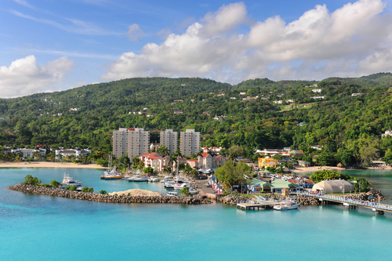
© clipdealer

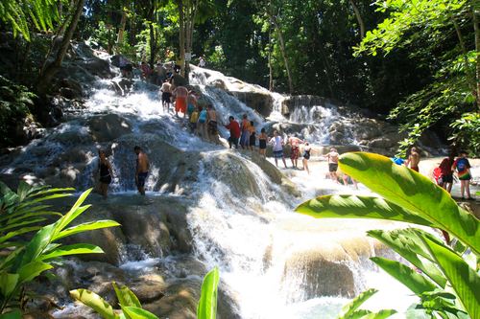
© clipdealer, Dunn River Falls

M 2 A Negative impact of tourism on the environment: Key areas

M 3 A Jamaican Tourism Board Statistics
Population (2020): 2 808 570
year | visitor arrivals | visitor expenditure [million USD]
2000 | 2 231 765 | no data
2009 | 2 754 331 | 1 925
2019 | 4 233 266 | 3 639

year | air passengers | German visitors | cruise passengers to Jamaica
2015 | 2 554 495 | 20 500 | 1 568 472
2019 | 3 257 119 | 24 100 | 1 551 690
Source: Annual Tourism Report of the Jamaican Tourism Board (https://www.jtbonline.org/report-and-statistics/, 03/21/2023)

M 4 A Carbon Footprint Results for the Trip to Jamaica, German Federal Environmental Agency (“Umweltbundesamt”) Calculator

Transcontinental Flight (1 passenger, Munich to Jamaica, duration: 11 hours)
CO₂-emission: 2,64 tons

Ship Cruise (1 passenger, 10 days)
CO₂-emission: 2,4 tons

Car (10 000 km per year, average-sized car)
CO₂-emission: 2,24 tons

Heating (per year, natural gas, 4 persons, 100 m², condominium built 1995–2001)
CO₂-emission: 0,25 tons
Source: https://uba.co2-rechner.de/de_DE/mobility-travel (12/01/2021)

M 5 A Useful links for general information about Jamaica (economy, geography, population)

https://www.cia.gov/the-world-factbook/countries/jamaica/
or
https://mebis.link/gZDZFe

https://thecommonwealth.org/our-member-countries/jamaica
or
https://mebis.link/aotmb4

Material – Group B
M 1 B Nature in Jamaica
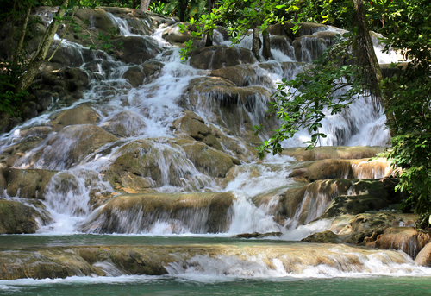

© clipdealer
© clipdealer, Dunn River Falls

M 2 B Land of Wood and Water – an excerpt from the “Jamaica Fact Sheet”, a brochure of the global environmental nonprofit organization “The Nature Conservancy”
The name Jamaica is derived from the Taino word “xaymaca”, which means “land of wood and water” and is fitting for a country where beauty flows from lush green mountains through crystalline rivers to a turquoise sea. […]. Forested slopes stretch the length of the island and are home to over 3,500 plant species, 900 of which are endemic. Jamaica also has an exceptional array of birds and reptiles, with more endemic species than any other Caribbean island. From the Blue Mountain range made famous by the coffee that bears its name to Pedro Bank […], the country’s natural treasures are its most valuable resources.
Source: https://www.nature.org/content/dam/tnc/nature/en/documents/Caribbean-Jamaica-Fact-Sheet.pdf, 03/21/2023

M 3 B UN Environment Programme: Jamaica
Jamaica is one of the most heavily indebted countries in the world, and the government has struggled to stimulate economic growth in order to break out of a pattern of stagnation, which has underpinned persistent poverty, high unemployment rates, high crime rates and large income inequalities.
Jamaica’s tourism industry has been the most successful in the competition for international markets. However, tourists are demanding cleaner and healthier environments, and enhanced efficiency. In addition, high expenditures on petroleum supplies from the international market are crippling local production, transportation, and consumption. The recovery of bauxite/alumina production has been stalled partly because of the insistence of the industry on cheaper energy supplies, which is pressuring the government to concede permission for coal-fired plants. Energy and security costs for manufacturing are excessive, and compounded by low labour productivity. High energy costs limit the competitiveness of the tourism and agricultural sectors as well. Consumers complain daily on the radio talk shows about the high electricity bills that they have to pay. […]
Source: https://www.unep.org/explore-topics/green-economy/what-we-do/advisory-services/caribbean-green-economy-project/jamaica (01/12/2021)

M 4 B Vision 2030 Jamaica: National Development Plan
Vision 2030 is the name of the national development plan of the Jamaican Government promoted by the slogan “Jamaica, the place of choice to live, work, raise families and do business”. Jamaica aims to become a developed country by 2030 and intends to achieve certain standards.
There are four general goals
relating to society, security,
economy, environment…
… and the corresponding standards which include among others :

Source: http://lslandr.com/vision2030/national-goals-and-outcomes/ (12/01/2021)

Hinweise zum Unterricht
Die Lernaufgabe setzt einen ersten Impuls zur Auseinandersetzung mit dem Thema Ferntourismus in der Karibik und dem damit verbundenen Entwicklungspotenzial für die Region am Beispiel Jamaikas. Unter Einbeziehung des bereits erworbenen Vorwissens der Schülerinnen und Schüler (zum Beispiel zur Problematik des Klimawandels) können die Schülerinnen und Schüler selbstständig Ideen entwickeln und ihr eigenes Handeln reflektieren.

Possible findings
geographical factors:
superb natural features: tropical climate all year round, no seasons (July to November: danger of hurricanes), warm Caribbean Ocean, diverse tropical vegetation, island: many beaches, harbours for cruise ships, mountains and coastal plains, close to USA

economic factors:
- Jamaican economy is heavily dependent on services, more than 70% of GDP
- derives most of its foreign exchange from tourism
- constant growth of expenditures and visitors
- unemployment rate: 12.2% (2017 est.), country comparison: 162 in the world
- population below poverty line: 17.1% (2016 est.)

environmental factors:
- high energy + water consumption, sewage + garbage disposal
- infrastructure + land use vs. protection of natural habitats
- impact on marine life (corals, plastic, …)
- traffic + transportation: CO2 emissions, air pollution, noise
- C2 emissions of air traffic + passenger ships cause climate change (ocean water temperatures/ sea levels, coral bleaching, growing danger of hurricanes ...)
- …

a visitor stays more than 24 hours, no cruise passengers or excursionists

