Media coverage of the Vietnam War

Stand: Mai 2025

|  |  |
| --- | --- |
| **Jahrgangsstufe** | 9, Lernbereich 9.5: Weltpolitik im Kalten Krieg |
| **Fach** | Geschichte |
| **Übergreifende Bildungs- und Erziehungsziele** | Politische Bildung  Sprachliche Bildung |
| **Zeitrahmen** | 2 Unterrichtsstunden |
| **Benötigtes Material** | * Internetzugang * zweisprachiges Wörterbuch |

# Kompetenzerwartungen

Die Schülerinnen und Schüler ...

* erläutern die Folgen der Blockbildung für Deutschland und die Welt sowie die Auswirkungen des *Kalten Kriegs* auf die Menschen in verschiedenen Teilen der Welt. (Urteilskompetenz)
* analysieren Bildquellen zum Vietnamkrieg, um den Einfluss der kritischen Berichterstattung auf den politischen Entscheidungsprozess zu erkennen.   
  (Methodenkompetenz, Urteilskompetenz, Orientierungskompetenz)

Inhalte zu den Kompetenzen:

* Vietnamkrieg als Beispiel für einen Stellvertreterkrieg

# Lesson Plan

## Lead-in:

The war in Vietnam has been described as the first “living room war”. In 1966 93 % (compared to only 9 % in the 1950s) of the American households owned a television; news magazine circulation rose to an average of 38 million readers per week. Thus, combat was seen on TV screens as well as in newspapers or magazines by a majority of the American public on a daily basis. Newspaper and television crews documented this war much more intensely than they had earlier conflicts. This extended to the military’s own photographers, who captured thousands of images of the conflict between 1962 and 1975. In this lesson, you will study and analyse some of these photographs to understand and discuss their impact during and on the Vietnam War.

## Central question:

How did media coverage influence and shape public opinion as well as the decision-making processes on governmental level during the Vietnam war?

## Tasks:

1. Imagine you are working for an influential political magazine in the 1960s. Your task is to create a cover on the Vietnam war for the next issue and to present and defend it in the editorial meeting.
   1. Share out the different photographs of the Vietnam war (M 1 – M 6).
   2. Analyse your photograph. Use the internet to research its context. Work on your own and sum up your findings in short and informative form.
   3. Find 3 other students who have analysed the same image and compare your results. Then prepare the cover for the next edition of your magazine, using your photo as central element. Decide how to place the image, add a background, suitable headline and caption.
   4. Get together for the editorial meeting, in which each group presents their cover and the story behind it in a short informative talk.
   5. Evaluate each other’s presentations and decide which cover to choose for the next issue. Also discuss the impact the photos have on you and consider what their impact might have been during the time of the Vietnam War*.*
2. “The White House soon learned that pictures can be hazardous to foreign policy.”

(CBC [=a major broadcasting cooperation] in its “Vietnam and TV News”.)

1. Discuss and speculate on the meaning of this statement taking into account your research so far.
2. Then read text M 7 and use the information to answer the central question.

Optional: Create a poster with your cover in the centre, on which you collect important facts on media coverage and its influence during the Vietnam war.

1. Optional topics for further discussion and reflection:
   1. A study authorized by the Trilateral Commission in 1975 to examine the "governability" of American democracy found that "the most notable new source of national power in 1970, as compared to 1950, was the national media.”

(DeBenedetti, Charles, [An American Ordeal: The Antiwar Movement of the Vietnam Era](https://archive.org/details/americanordealan00debe); Syracuse 1990.)

Discuss the function and role of the media in a democratic society. Consider positive and negative aspects.

*Tip: Use the terms “watchdog, 4th estate, manipulation, propaganda”.*

* 1. Can pictures lie?  Discuss whether photographs tell the true story of what happened in Vietnam or whether they are just a subjective construction of reality. Use M 8 as basis of your discussion.

**Word bank**

**news coverage** – Berichterstattung

**war correspondent** – Kriegsberichterstatter

**frontline coverage** – Berichterstattung von der Front

**censorship** – Zensur

**proxy war** – Stellvertreterkrieg

**to depict sth**. – etwas anschaulich darstellen

**Cold War** – Kalter Krieg

**Eastern, Communist or Soviet Bloc** – Ostblock

**Western or Capitalist Bloc, Western Powers** – Westmächte

**Vietnam (1955 to 1975) – North Vietnam, officially the Democratic Republic of Vietnam (DRV) and South Vietnam, officially the Republic of Vietnam (RVN)**

**peace rally; anti-war demonstration** – Friedenskundgebung

**cover (of a magazine) –** Titelblatt

**issue (of a magazine), edition (of a book)** – Ausgabe (einer Zeitschrift / eines Buchs)

**caption** – Bildunterschrift

**editorial meeting** – Redaktionssitzung

**the navy** –die Marine

**a marine** – ein Marinesoldat

**US Navy Seals** – US-Marineeinheit

**air force** – Luftwaffe

**U.S. armed forces** – Streitkräfte der USA

**department of defense** - Verteidigungsministerium

# Material

M 1  
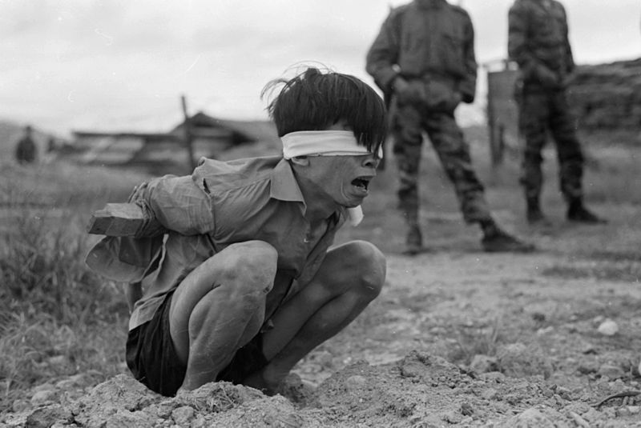

A Viet Cong prisoner is interrogated at the A-109 Special Forces Detachment in Thuong Duc, 25 km west of Da Nang, Vietnam.

Date: 23/1/1967

Source/Photographer: PFC David Epstein (PFC = Privat First Class, a fairly low rank in the army)

Link: <https://de.wikipedia.org/wiki/Datei:Vietconginterrogation1967.jpg> (25/11/2024)

Source: PFC David Epstein, Link: <https://de.wikipedia.org/wiki/Datei:Vietconginterrogation1967.jpg> (25/11/2024), Public Domain

## M 2

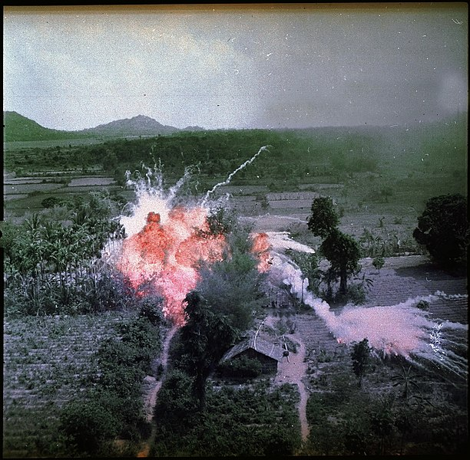Napalm bombs explode on Viet Cong structures south of Saigon in the Republic of Vietnam.

Date: 1965

Source/Photographer: U.S. Air Force

Link: <https://de.wikipedia.org/wiki/Datei:Napalm.jpg>

Source: U.S. Air Force, Link: <https://de.wikipedia.org/wiki/Datei:Napalm.jpg> (25/11/2024), Public Domain

## M 3

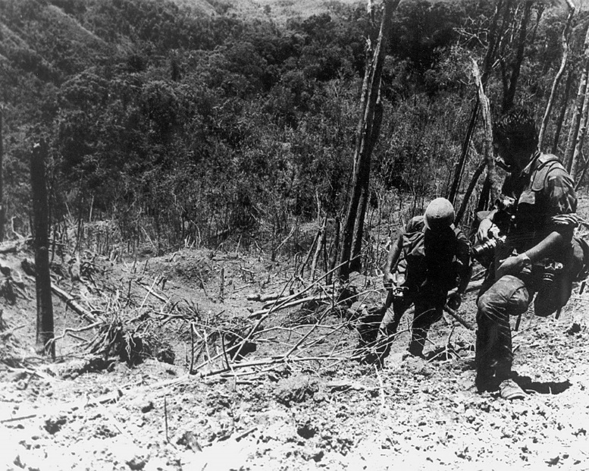

A U. S. Army Photographer and assistant climbing through the devastated landscape on Dong Ap Bia after the battle.

Date: 31 May 1969

Source/Photographer: United States Army Military History Institute (USAMHI)

Link: <https://commons.wikimedia.org/wiki/File:Soldiers_of_the_101st_Airborne_Division_climb_Hamburger_Hill_after_the_battle_in_May_1969.jpg>

Source: United States Army Military History Institute (USAMHI), Link:   
<https://commons.wikimedia.org/wiki/File:Soldiers_of_the_101st_Airborne_Division_climb_Hamburger_Hill_after_the_battle_in_May_1969.jpg> (25/11/2024), Public Domain

## M 4

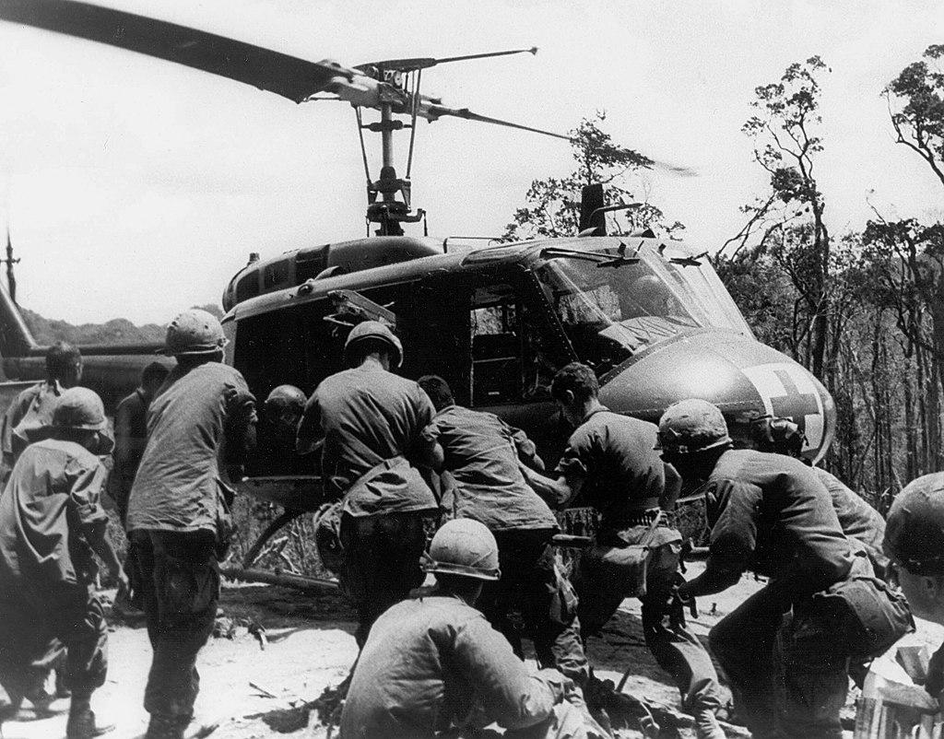

Wounded Soldiers are loaded on to a UH-1 medevac helicopter during Operation Apache Snow. (*medevac = MEDical EVACuation*)

Date: 31 May 1969

Source/Photographer: United States Army Military History Institute (USAMHI)

Link: <https://www.army.mil/article/38997/rakkasans_on_hamburger_hill>

Source: United States Army Military History Institute (USAMHI), Link: <https://www.army.mil/article/38997/rakkasans_on_hamburger_hill> (25/11/2024), Public Domain

## M 5

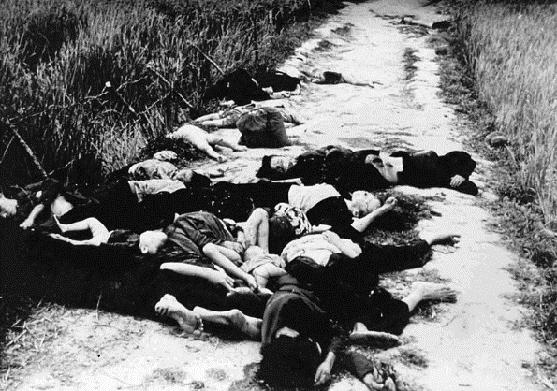

Unidentified Vietnamese bodies on road.

Date: 16 March 1968

Source/Photographer: Ronald L. Haeberle; Report of Army review into My Lai incident, book 6, 14 March 1970

Link: <https://commons.wikimedia.org/wiki/File:Dead_from_the_My_Lai_massacre_on_road.jpg>

Photographer: Ronald L. Haeberle, Link: <https://commons.wikimedia.org/wiki/File:Dead_from_the_My_Lai_massacre_on_road.jpg> (25/11/2024), Public Domain

## M 6

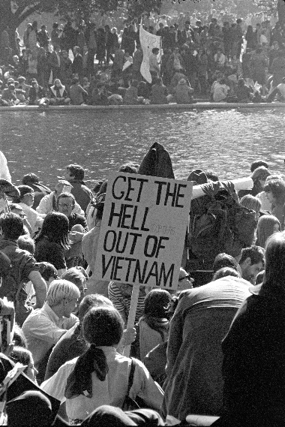

Vietnam War protestors march at the Pentagon in Washington, D.C. on October 21, 1967.

Date: 21 October 1967.

Source/photographer: Frank Wolfe; Lyndon B. Johnson Library

Link: <https://de.m.wikipedia.org/wiki/Datei:Vietnam_War_protestors_at_the_March_on_the_Pentagon.jpg>

Source: Lyndon B. Johnson Library, Link: <https://de.m.wikipedia.org/wiki/Datei:Vietnam_War_protestors_at_the_March_on_the_Pentagon.jpg> (25/11/2024), Public Domain

## M 7 The role of the media in the Vietnam War

**The media in the 1960s**

The evolution of media went side-by-side with the Vietnam War. New technologies such as video cameras and audio recorders spread. In 1966, 93% of the households in the US owned a television. In addition, news magazines reached about 38 million readers per week. Government control of all the material soon became impossible. The media was thus able to publish uncensored images of the Vietnam War. These were seen by millions of Americans on a daily basis during what has been described as the first ‘television war’.

**Development of news coverage during the Vietnam War**

As the war became more intense, the number of reporters in Vietnam increased rapidly. From just 40 in 1964, the number grew to 419 in 1965. At this time, the US involvement in Vietnam was generally supported by the media. However, the situation soon changed. In 1968, the Tet Offensive, a series of attacks by North Vietnam, which resulted in heavy US casualties, marked a turning point in the media’s coverage of the war. From then onward, the reports became predominantly negative. Images of both civilian and military casualties were increasingly televised. As the war became uglier on screen, its public support declined significantly. In 1965 only 24 % of the Americans had believed that it was a “mistake to send troops to Vietnam” according to a Gallup poll. In 1968, the number increased to 54 %. With the revelation of the My Lai Massacre in November 1969, the media further intensified public shock and outrage. The press published material of Army photographer Ronald Haeberle, who had secretly taken two sets of images. While the film on the Army owned camera showed ‘official’ operations including interrogating villagers and burning 'insurgent' huts, Haeberle's personal images showed hundreds of villagers, primarily women and children, who had been killed by U.S. troops. The war was now depicted as one of the biggest crimes in U.S history and the government’s credibility was critically damaged.

**Impact of the media coverage on political decision-making**

As the war became more unpopular, protests and demonstrations spread throughout the country - at first against the war and, later, against the government who waged it. The growing discontent of the public - extensively covered in the news media - became a matter of concern to the US government. White House employees monitored the media and President Johnson regularly consulted with his aides to see how the press would react to announcements and postponed the revealing of unpopular decisions. In 1968, under tremendous public pressure, he called to begin peace talks and decided not to seek re-election. His successor, President Nixon, began to gradually withdraw the U.S. forces from Vietnam. He reflected on the media’s role in the Vietnam war:

“[T]he American news media had come to dominate domestic opinion about its [=the war] purpose and conduct […]. In each night’s TV news and in each morning’s paper the war was reported battle by battle, but little or no sense of the underlying purpose of the fighting was conveyed. Eventually this contributed to the impression that we were fighting in military and moral quicksand, rather than toward an important and worthwhile objective. More than ever before, television showed the terrible human suffering and sacrifice of war. Whatever the intention behind such relentless and literal reporting of the war, the result was a serious demoralization of the home front, raising the question whether America would ever again be able to fight an enemy abroad with unity and strength of purpose at home”.

Source: own summary, based on the following sources:

# PBS Learning Media: News Stories of Vietnam (background reading); <https://www.pbslearningmedia.org/resource/news-stories-of-vietnam/news-stories-of-vietnam/support-materials/>

# PBS Learning Media: War on the Home Front; <https://www.pbslearningmedia.org/resource/vietnam-war-on-homefront/vietnam-war-on-homefront/>

# Matthew Cranker, The Impact Journalism had on the Vietnam War (Blog); in: [History and Journalism](https://historyandjournalism.wordpress.com/); 20/2/2016; <https://historyandjournalism.wordpress.com/the-impact-journalism-had-on-the-vietnam-war/>

# *National Archives Foundation – DocsTeach:* The War in Vietnam - A Story in Photographs; <https://www.docsteach.org/activities/student/the-war-in-vietnam-a-story-in-photographs>

# [Alan Rohn](https://thevietnamwar.info/author/rexyz/): Media Role in the Vietnam War; last updated on January 25, 2019; <https://thevietnamwar.info/media-role-vietnam-war/2/?vietnam-war-events=media-role-vietnam-war>

* <https://en.wikipedia.org/wiki/Pentagon_Papers> and <https://en.wikipedia.org/wiki/United_States_news_media_and_the_Vietnam_War>
* Daniel C. Hallin, The Uncensored War: The Media and Vietnam, London u.a. 1989.
* Richard Nixon, The Memoirs, New York 1978, p.350. (*Quote Nixon*)

## M 8 Images as construction of reality?

* Compare the images a/b and explain how the different representations change your emotional response and perception of what happened.
* Add different captions to one of the pictures and discuss how changing the caption alters the impact of the picture.

a

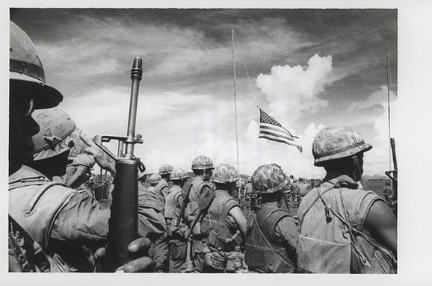

Fourth Marine Regiment salute fallen Marines during Memorial Services held at Khe Sanh Combat Base. The unit of the 3d Marine Division was joined by soldiers of the Army of the Republic of Vietnam during the Memorial Services.   
Photo by SSgt (= Staff Sergeant) Fred Lowe III;

Date: 19 June 1968.

a) <https://commons.wikimedia.org/wiki/File:Company_K,_3.4_Marines_at_a_memorial_service_at_Khe_Sanh_Combat_Base.jpg>

b) <https://www.defense.gov/Multimedia/Photos/igphoto/2001338365/>

b

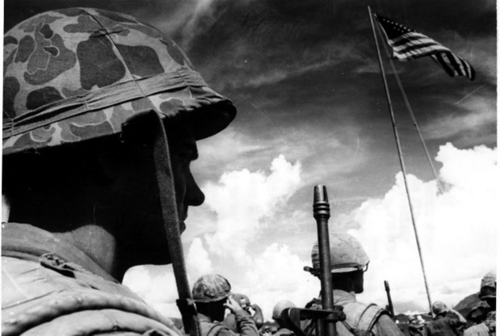

Source: a) Official USMC photo by Staff Sergeant Fred Lowe III from the Jonathan F. Abel Collection (COLL/3611) at the Archives Branch, Marine Corps History Division; Link: <https://commons.wikimedia.org/wiki/File:Company_K,_3.4_Marines_at_a_memorial_service_at_Khe_Sanh_Combat_Base.jpg> (25.11.2024), This image was originally posted to [**Flickr**](https://en.wikipedia.org/wiki/Flickr) by Archives Branch, USMC History Division at <https://flickr.com/photos/60868061@N04/28717438273>. It was reviewed on 28 April 2023 by [**FlickreviewR 2**](https://commons.wikimedia.org/wiki/User:FlickreviewR_2) and was confirmed to be licensed under the terms of the cc-by-2.0.

b) Marine Corps photo by SSgt Fred Lowe III, U.S. Department of Defense; Link:  
<https://www.defense.gov/observe/photo-gallery/igphoto/2001338365/> (25.11.2024)   
(“The appearance of U.S. Department of Defense (DoD) visual information does not imply or constitute DoD endorsement.”)