The Genetic Blueprint of Humans
Task 1  The following text describes the organization of genetic information in your body. Use the words given below to fill in the blanks. Work alone or in pairs. | 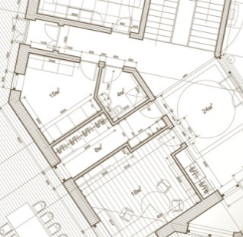
centromere, nucleus, chromosomes, novel, dye, development, muscle,
control center, sister chromatids, microscope, size, plant, genome
The instructions for the building of our bodies (and, for that matter, the body of any animal, ………………….…., and bacterium) are stored in the body as genetic information. The sum of this information is called the “………………..……“ of an organism. But genetic information is not only required once in a lifetime to build the body during embryonic …………………... Rather, the genome is the …………………….. of a cell.
Just as the managing board controls a company, it controls the entire cell. Therefore, a complete copy of the genome is found in every single cell of the body.However, not all parts of this genetic information will be used in every cell. For example, nerve cells use a different set of genetic instructions than ……………….… cells. In fact, what makes a cell a skin cell or a liver cell is the combination of genetic instructions used in that cell. |  | 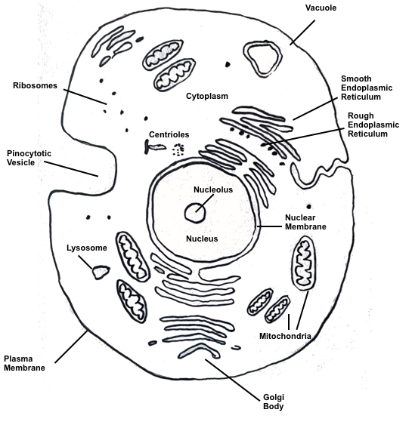
The genetic information in a cell is found in the ………………… (see figure above of a typical animal cell). It contains „X“-shaped structures. Each of these so-called ……………………….. consists of two ……………….. …………………………… held together at the ………………………… (see figure on the right). The chromosomes store genetic information just like books store the information of a …………….…………. . The chromosomes can be isolated from cells (e.g. blood cells), stained with a specific ………………………., and then visualized under a ………………….……… . The chromosomes differ in ….…………., location of the centromere, and pattern of light and dark bands. Therefore, scientists can distinguish different chromosomes and assemble them in a specific order (the longest chromosome is referred to as chromosome 1, the second longest as chromosome 2, and so forth). The ordered representation of all the chromosomes of an organism is called a „karyotype“. |  |  |  | 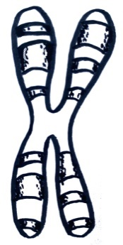
Task 2
”Think, pair, share“: The figure shows the karyotypes of a male (on the left) and a female (on the right) human, respectively. Examine both karyotypes and make statements about the karyotype of a human (= think; 2 min). Then discuss your results with your seatmate (= pair; 5 min). You should come up with at least three important statements of the type „The human genome consists of …“; „Male individuals have …, whereas …“). In the end, be prepared to present your findings to the class (= share; 3 min)
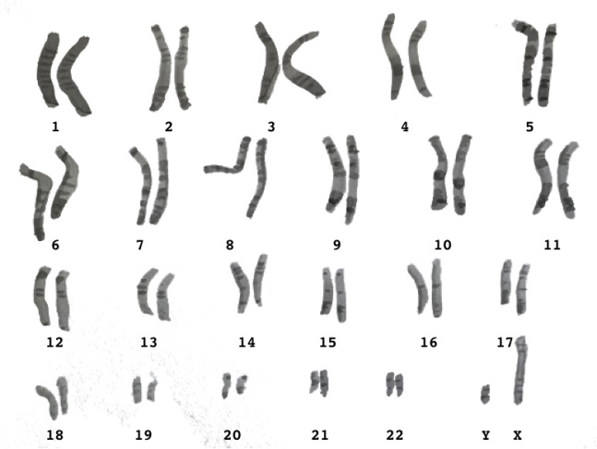 | 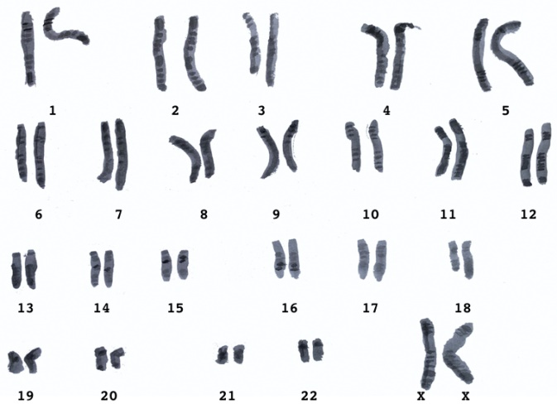

Key data of the human karyotype:
……………………………………………………………………………………………………..……..
……………………………………………………………………………………………………..……..
………………………………………………………………………………………………..…………..
……………………………………………………………………………………………………….………
……………………………………………………………………………………………….………………
………………………………………………………………………………………….……………………
Exceptions to the rule:
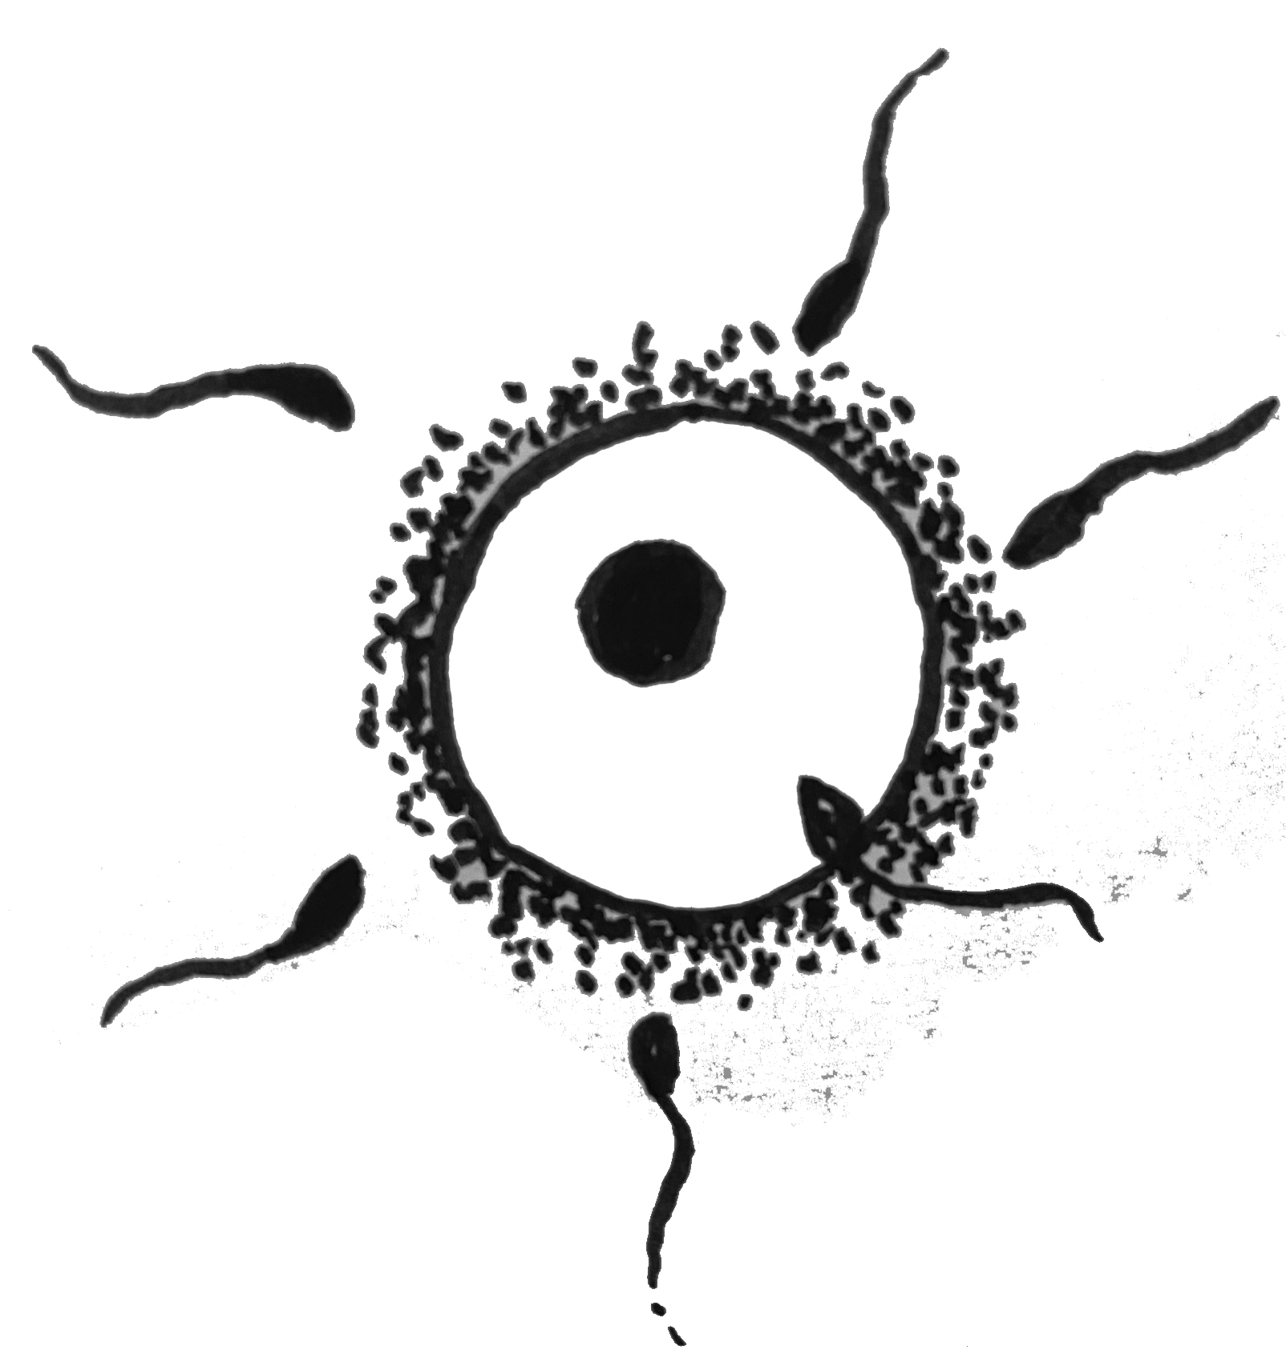
1. ………………………………………………………………………………….………
2. …………………………………………………………………………….……………
3. ……………………………………………………………………….…………………
- ……………………………………………………………………..…………………
- ……………………………………………………………………..…………………
- ……………………………………………….………………….…………………...

Task 3
“Think, pair, share“. In newborn babies one can find three types of trisomy (involving chromosomes 13, 18, and 21). Consider why no trisomies of other chromosomes (e.g. involving chromosome 1) occur in humans and frame a hypothesis.
………………………………………………………………………………………………..…………..
……………………………………………………………………………………………………….………

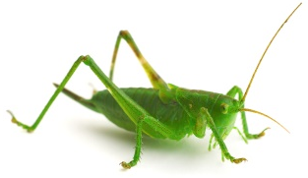
Task 4
Complete the sentence.
If a muscle cell in a grasshopper contains 24 chromosomes,
then a grasshopper sperm cell contains …… chromosomes.
Grafiken: ISB
Fotos: © Clipdealer

