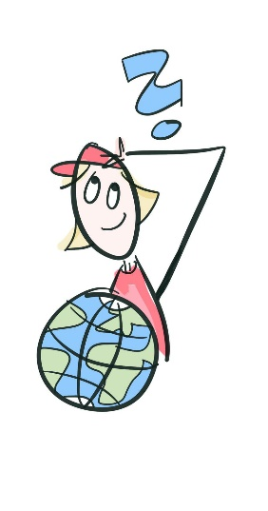
Quiz for bilingual classes: year 8

- Which two countries contain the largest parts of the Taiga?
- Russia / Canada
- What is the official currency of India?
- rupees
- In which country can you find the highest mountain on earth and what’s its name?
- Nepal / Mount Everest
- What’s the second highest mountain?
- K2
- What’s the most northern US state?
- Alaska
- How many states does the USA have?
- 50
- Which country is north of the USA?
- Canada
- How many oceans does the equator cross?
- 3
- Name five “treasures” you can find in Siberia.
- gold, silver, natural gas, timber, copper
- Which island can be found south-east of India?
- Sri Lanka
- Which mountain range separates Europe from Asia?
- The Ural Mountains
- What’s the capital city of Mexico?
- Mexico City
- What’s the name of the tropical rainforest in South America?
- Amazon
- Which country is the largest one in South America?
- Brazil
- Name two Central American countries.
- Guatemala / Panama / …
- Which canal is the border between North and South America?
- Panama Canal
- Which river is called the holy river of the Hindus?
- Ganges
- Which two countries are the most southern ones of South America?
- Argentina / Chile
- Which river in China is also called the Yellow River?
- Huang He
- What’s the capital city of China?
- Beijing

