Material

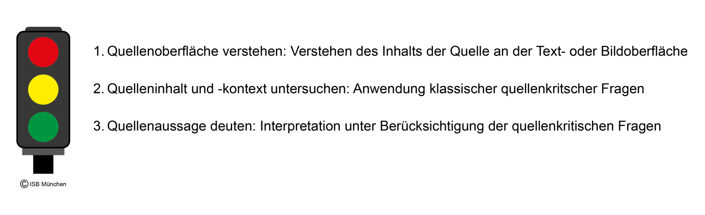

Analog zum Ampelmodell für die Erschließung von Bild- und Textquellen (vgl. Servicebereich von LehrplanPLUS Geschichte 6 > Materialien zu Methoden Geschichte 6: Umgang mit Quellen) finden Sie hier zwei editierbare Vorlagen für Scaffolding-Materialien, die die Schülerinnen und Schüler im Bilingualen Zug als sprachliche Hilfestellung verwenden können.

Hinweis:

Je nach Quelle (Bild oder Text) muss der quellenspezifische Wortschatz in den jeweils rechten Spalten der Tabellen vorab von der Lehrkraft je nach benötigtem Vokabular angepasst werden.
M1 „Method box: pictorial sources“
Steps | Chunks | Wise up
1 Describe the picture |  | Quellenspezifischer Wortschatz, z. B.
- Who/What does it mainly show?  - What can you see?  - What are the people doing?  - What details are there?  - What`s happening?  - Are there any symbols/details?  - Where are the symbols, things, people aso.?  - … | The picture is mainly about …  There is/are …  People are …  The colours are …  Some objects are …  I guess the … shows that …  on the right / on the left / in the middle / at the top / at the bottom … | orb Reichsapfel  fur Fell  ermine Hermelin  coat Mantel  sceptre Zepter  splendid prächtig  …

Steps | Chunks | Wise up
2 Find out about the picture
- When and where was the picture created?  - Who created it?  - For whom was it possibly made?  - Who possibly ordered it?  - Where was it published?  - What`s the meaning of peoples`/things`/symbols` position?  - … | The picture was created when/at/for/in …  It was found in …  … painted/drew/created it.  … ordered it.  It was shown at …/published in …  … | title Titel  drawing Zeichnung  coronation Krönung  client Auftraggeber  meaning Bedeutung  …

3 Comment on the picture
- What does the information in the picture tell us?  - What`s the message of the picture?  - What does the painter want to show us?  - Is the painter neutral?  - Why was it made?  - Why was it created like that?  - Where can I find further information?  - What did I learn about the perspective of the picture (= the way it is created by the painter)?  - What do I think about it today? | Personally, I …  I think …/In my opinion …  The painter wants to show that…  Maybe he was influenced by…  I found out that…  I learnt that…  It`s interesting to see… | position of power  Machtposition  (un)realistic  (un)realistisch  perspective  Perspektive  opinion/view  Meinung

M2 „Method box: written sources“
Steps | Chunks | Wise up
1 Describe/Explain the content
What`s the main topic of the text?  What people and places are mentioned in the text?  What does the text say about actions?  Which symbols are mentioned in the text?  Are there any other important details in the text?  Important people? Place? Ceremony? Insignia? … | The text is mainly about …  There is/are …  People are …  … is mentioned.  There is some more information about…  … | coronation Krönung  archbishop Erzbischof  princes Fürsten  dukes Herzöge  people Volk  staff Stab  sword Schwert  gown Mantel/Umhang  anoint salben  ...

Steps | Chunks | Wise up
2 Find out about the text
What kind of text is it?  When/where was the text written?  Who wrote it?  For whom was it possibly written?  Who possibly ordered it?  Who published it?  When was it published?  What`s the meaning of peoples/things symbols/position? | It is a speech/a letter/a report/ an article etc…  The text was written when/at/for/in …  … wrote it.  … ordered it.  … published it./  It was published in…  The meaning of … is…  The symbols meant that… | speech Rede  report Bericht  author Autor  client Auftrraggeber  meaning Bedeutung  …

3 Comment on the text
What does the information in the text tell us?  What`s the message of the text?  What does the author want to show us?  Is the author neutral?  Why was the text written?  Where can I find further information?  What did I learn about the perspective of the text (= the way it is written by the author)?  What do I think about it today?  … | Personally, I …  … it was written because …  I think …  In my opinion …  The author wants to show that…  The author wrote it in this way because…  Maybe he was influenced by…  I found out that…  I learnt that……  It`s interesting to see… | position of power Machtposition  (un)realistic  (un)realistisch  perspective  Perspektive  opinion/view Meinung

