“Propaganda Posters (First World War)”
Stand: 19.07.2021
Jahrgangsstufe | 9 (auf Englisch)
Fach/Fächer | Geschichte / Bilingualer Zug
Übergreifende Bildungs- und Erziehungsziele | Interkulturelle Bildung, Politische Bildung, Werteerziehung, Sprachliche Bildung
Zeitrahmen | 2 Unterrichtsstunden
Benötigtes Material | Einstieg, Worksheets, Posters (M1-M6)

Kompetenzerwartungen
G9 LB 1: Methoden und Arbeitstechniken
Die Schülerinnen und Schüler stellen quellenkritische Überlegungen zu Quellenart, Urheber, Adressat und dem historischen Kontext an (z. B. bei Karikaturen, politischen Reden, Zeitungsartikeln). Insbesondere analysieren sie dazu politische Propaganda in einschlägigen Bild- und Textquellen (z. B. Wahlplakate, politische Reden) sowie in historischen Film- und Tondokumenten (z. B. Propagandafilme/-lieder) und beschreiben deren manipulative Intentionen.
G9 LB 2: Imperialismus und Erster Weltkrieg
Die Schülerinnen und Schüler analysieren die Kriegspropaganda des Ersten Weltkriegs vor dem Hintergrund der Situation von Soldaten und Zivilbevölkerung. Sie wenden ihre Kenntnisse kritisch auf andere Propagandabeispiele an, um die Rolle von Propaganda allgemein zu begreifen.

Hinweise zum Unterricht
Zunächst bietet sich das Wiederholen der Situation in der Heimat und an der Front, ggf. mit Schulbuch an. Danach sollte das Einführen eines Propagandaplakates folgen. Die Frage wir nun thematisiert: What is propaganda? Eine Musteranalyse des Propagandabildes ‘Women of Britain say – “Go!“‘ dient als Vorbild für weitere Schritte, dabei werden parallel die Ampel-Schritte der Musteranalyse an der Tafel fixiert. Die Analyse je eines Propagandabildes durch Schülerinnen und Schüler in Gruppen stellt das Stundenziel dar. In der darauf folgenden Stunde wird ein Gallery-Walk zu den Ergebnissen der Schülerinnen und Schülerdurchgeführt, dieser könnte auch online erfolgen.

1. Quellenoberfläche verstehen

a. Beschreibe die einzelnen Bildelemente (Bildelemente, Farben, Komposition,
Perspektive).
b. Kläre, für was die Bildelemente, Farben, Komposition, Perspektive stehen
könnten.


M1 Method box: pictorial sources
Steps | Chunks | Wise up
1 Describe the picture |  | Quellenspezifischer Wortschatz, z. B.
- Who/What does it mainly show?  - What can you see?  - What are the people doing?  - What details are there?  - What’s happening?  - Are there any symbols/details?  - Where are the symbols, things, people etc.?  - … | The picture is mainly about …  There is/are …  People are …  The colours are …  Some objects are …  I guess the … shows that …  on the right / on the left / in the middle / at the top / at the  bottom … | soldier Soldat  landscape Landschaft  rifle Gewehr  fearful ängstlich  to clutch (sich)  festhalten  connection Verbindung  …

2. Quelleninhalt und -kontext untersuchen

a. Kläre den historischen Hintergrund bei der Entstehung des Bildes.
b. Kläre, von wem das Bild in Auftrag gegeben wurde.
c. Kläre, an wen sich das Bild wendet.
d. Formuliere die Botschaft, die der Auftraggeber mit dem Bild dem Empfänger
mitteilen will. Achtung: Begründe Deine Aussage mit dem Bild!

Steps | Chunks | Wise up
2 Find out about the poster
- When and where was the poster  created?  - For whom may it have been made?  - Who may have ordered it?  - Where was it published?  - What’s the significance of the position of people/things/  symbols ?  - … | The poster was created when/at/for/in …  It was found in …  … printed/drew/created  it.  … ordered it.  It was shown at …/published in …  … | title Titel  drawing Zeichnung  farewell Abschied  client Auftraggeber  significance Bedeutung  …

3. Quellenaussage deuten

a. Stelle dar, welche Absicht der Auftraggeber mit seinem Bild verfolgt. Achtung:
Begründe Deine Aussage mit dem Bild!
b. Formuliere aus Deiner Sicht eine kritische Stellungnahme zu dem Bild und
seiner Botschaft.

3 Comment on the poster
- What’s the message of the poster?  - What does the creator want to show us?  - Is the creator neutral?  - Why was it made?  - Why was it created like that?  - What did I learn about the perspective of the picture (= the way it was created)?  - What do I think about it today? | Personally, I …  I think …/In my opinion …  The creator wants to show that…  Maybe he was influenced by…  I found out that…  I learnt that…  It’s interesting to see… | position in society  gesellschaftliche  Position  realistic  realistisch  perspective  Perspektive  opinion/view  Meinung

Beispielanalyse von Propagandaquellen zu M2 „Woman of Britain say – ‚Go!‘“

1. Understanding the source surface
a) Description of the poster elements. In the foreground you can see two young women hugging each other and you can see a small boy, who is clutching the woman’s dress. All three are anxiously looking out of the window. You can see soldiers passing by the window in a green landscape. The slogan at the top is ‘Women of Britain say – “Go!“‘
b) Explaining the poster elements. The two women represent all British women, who bid their husbands farewell as they leave for war. The boy could be the son of one of the women. The soldiers are about to go to war. You can see a typical British landscape.

2. Examining the source context
a) Historical background
The British soldiers were part of the “Triple Entente“. At the beginning of World War I, there was no conscription in Britain. Therefore the British army was an army of
volunteers.
b) Client
The recruitment of soldiers was the most important task of the “War Propaganda
Bureau“. This institute created this poster.
c) Addressee
The poster is for British men who could become soldiers and also for British women because they could influence their menfolk…
d) Message
The poster lets the British men know that the British women want them to join the army as soldiers. This is what the title tells us.

3. Interpreting the message
a) Intention
The men are told that it is their duty to fight for their country.The central message ”GO!“ is therefore underlined. This would make the women proud of their sons or husbands. That is also the reason why they look out of the window in a wistful way. The women show a mixture of feelings. On the one hand they are proud and on the other hand they are anxious. That is why they are hugging each other while watching the soldiers leaving.
Women who look at this poster should take these women as a role model. They should not complain or doubt. Instead, like the women on the poster, they should be proud. The reason why one woman is blonde and the other has got brown hair is to adress a lot of different women.

b) Critical opinion
The men are put under pressure by this poster telling them that that they should join the army. Not joining it would be like betraying their wives and their families. The reality of war is not depicted at all.

Quellen und Literaturangaben
M2 ’Women of Britain say - "Go!"’, May 1915, United Kingdom, by Parliamentary Recruiting Committee, Hill, Siffken & Co. (L.P.A. Ltd.), E J Kealey. Gift of Department of Defence, 1919. Te Papa (GH016292). Public Domain (17.02.2021)

M3 Parliamentary Recruiting Committee – https://aptlyrandom.files.wordpress.com/2013/11/posters-5.jpeg. Public Domain (17.02.2021)

M4 Please credit UBC Library as the image source. For more information, see digitalcollections.library.ubc.ca/cdm/about. Creator: Unknown Date Created: 1914 Source: Original Format: University of British Columbia. Library. Rare Books and Special Collections. World War I Poster and Broadside Collection. Public Domain (17.02.2021)

M5 "Halt the Hun! Buy U.S. Government Bonds. Third Liberty Loan." U.S. Food Administration. Educational Division. Advertising Section. (01/15/1918 - 01/1919). Public Domain (17.02.2021)

M6 "Fight or Buy Bonds. Third Liberty Loan." U.S. Food Administration. Educational Division. Advertising Section. (01/15/1918 - 01/1919). Public Domain (17.02.2021)

M7 Harry R. Hopps, (1869-1937) – Dieses Bild ist unter der digitalen ID ds.03216 in der Abteilung für Drucke und Fotografien der US-amerikanischen Library of Congress abrufbar. Public Domain (17.02.2021)

Aufgabe

Useful expressions for your presentation:


  Phrases for developping questions…
  Why is there …?
  What kind of connection …?
  Which one is …? Why are there …?
  What do they …?
  Are there maybe …?

Phrases for presenting results …
Firstly, I’ll explain why / how ... | Let's (now) find out why / how ...
You probably know that ... | As I have already said ...
Hardly anyone knew / knows ... | One can say that ...
Maybe you've already heard about ... | This proves that ...
At the beginning there was / were ... | The reason is that ...
As we found out … | The result of this is that ...
The roots of ... go back to ... | It's because ...
Another aspect / point is that ... | In other words, ...
M1 Method box: pictorial sources
Steps | Chunks | Wise up
1 Describe the picture |  | Quellenspezifischer Wortschatz, z. B.
- Who/What does it mainly show?  - What can you see?  - What are the people doing?  - What details are there?  - What’s happening?  - Are there any symbols/details?  - Where are the symbols, things, people etc.?  - … | The picture is mainly about …  There is/are …  People are …  The colours are …  Some objects are …  I guess the … shows that …  on the right / on the left / in the middle / at the top / at the  bottom … | soldier Soldat  landscape Landschaft  rifle Gewehr  fearful ängstlich  to clutch (sich)  festhalten  connection Verbindung  …

Steps | Chunks | Wise up
2 Find out about the poster
- When and where was the poster  created?  - For whom may it have been made?  - Who may have ordered it?  - Where was it published?  - What’s the significance of the position of people/things/  symbols ?  - … | The poster was created when/at/for/in …  It was found in …  … printed/drew/created  it.  … ordered it.  It was shown at …/published in …  … | title Titel  drawing Zeichnung  farewell Abschied  client Auftraggeber  significance Bedeutung  …

3 Comment on the poster | Chunks | Wise up
- What does the information in the picture tell us?  - What`s the message of the picture?  - What does the painter want to show us?  - Is the painter neutral?  - Why was it made?  - Why was it created like that?  - Where can I find further information?  - What did I learn about the perspective of the picture (= the way it is created by the painter)?  - What do I think about it today? | Personally, I …  I think …/In my opinion …  The painter wants to show that…  Maybe he was influenced by…  I found out that…  I learnt that…  It`s interesting to see… | position in society  gesellschaftliche  Position  realistic  realistisch  perspective  Perspektive  opinion/view  Meinung

M2 Women of Britain say – ”GO!“
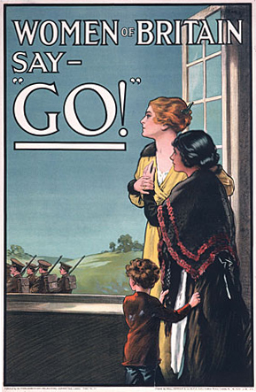

M3 Daddy, what did YOU do in the Great War? 1915

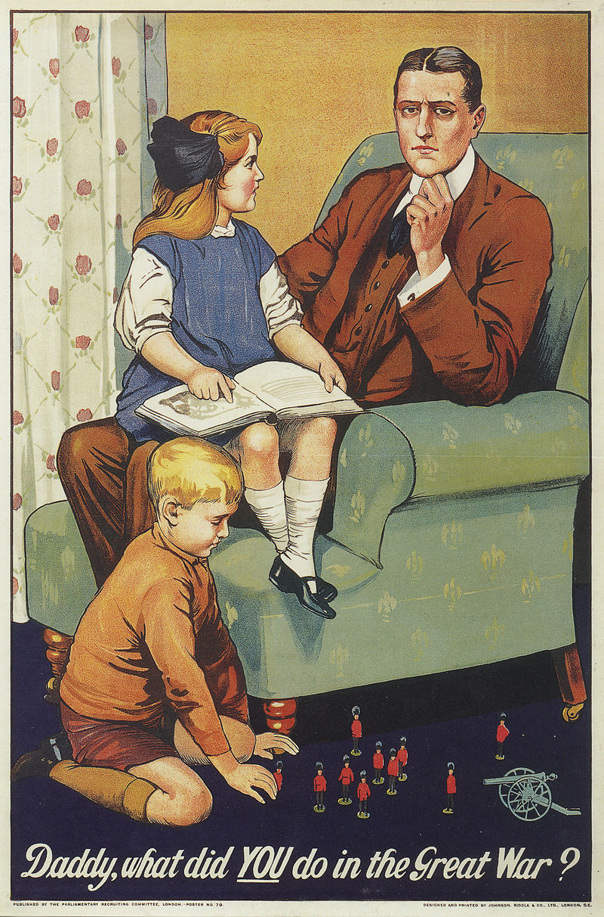

M4 The kitchen is the key to victory – eat less bread

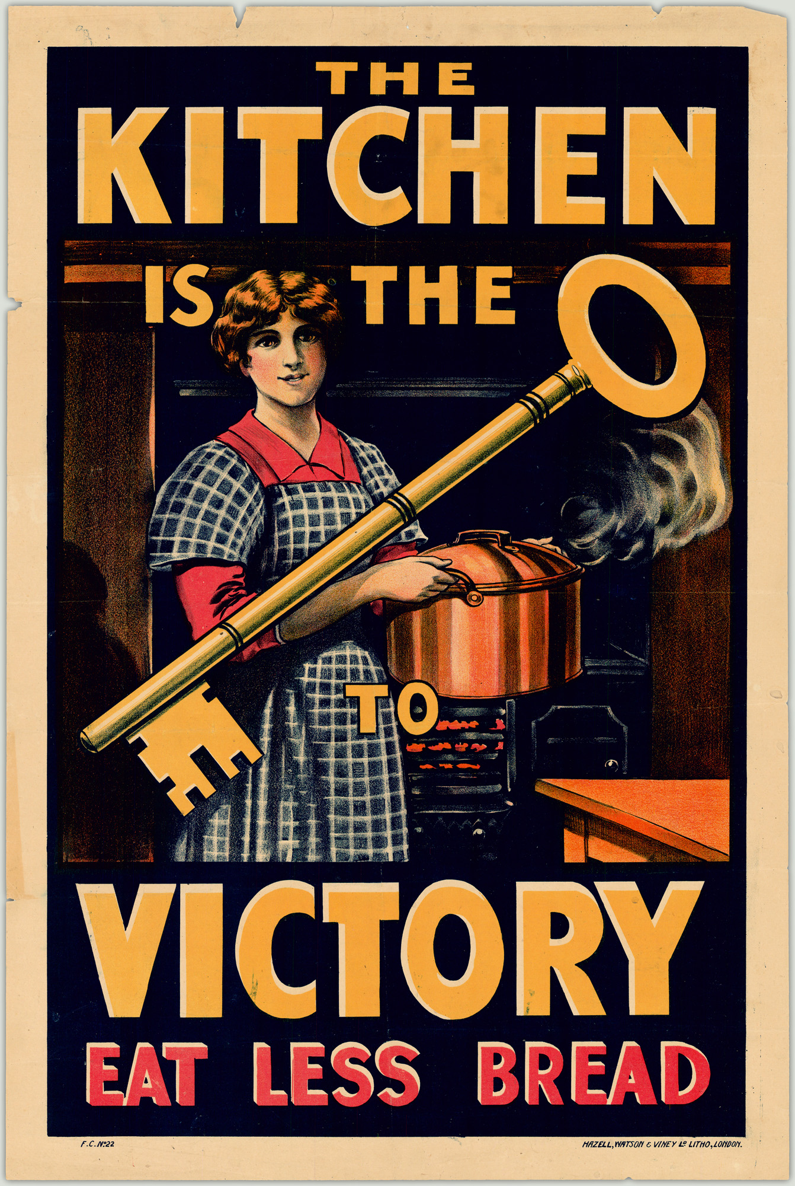

M5 HALT the HUN! Buy U.S. Government Bonds – Third Liberty Loan
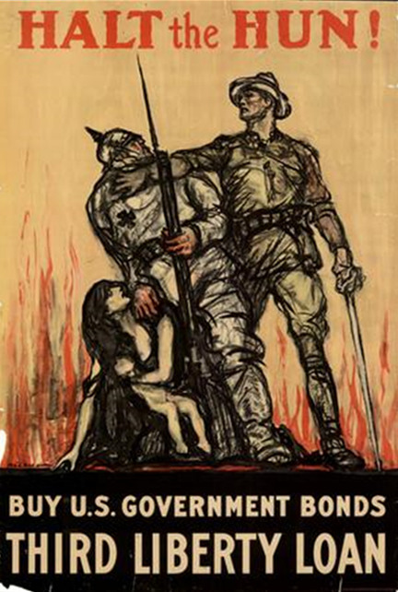

M6 Destroy this mad brute – Enlist 1917
