Step 1 Acquiring Knowledge
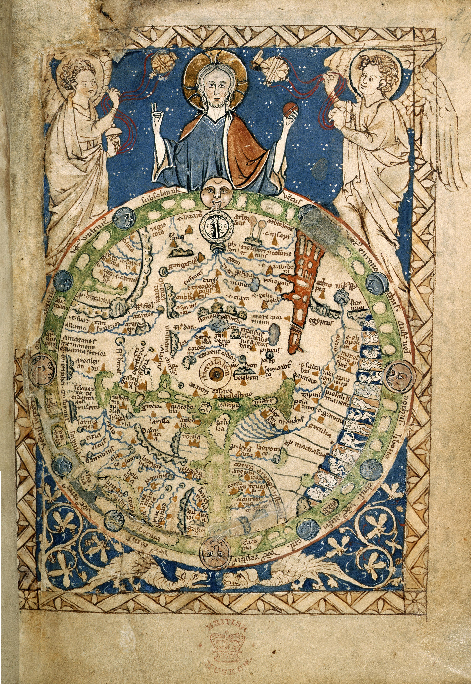M1

- M1 shows a 13th century world map (from about 1240).
- Find characteristics that show that the map is a Christian map.
- Find out which city was the most important one for Christians and describe how you can see this on the map.
___________________________________________________________________________________________________________________________________________________________________________________________________________________________________________________________________________________________________________________________________________________________________________________________________________
M2
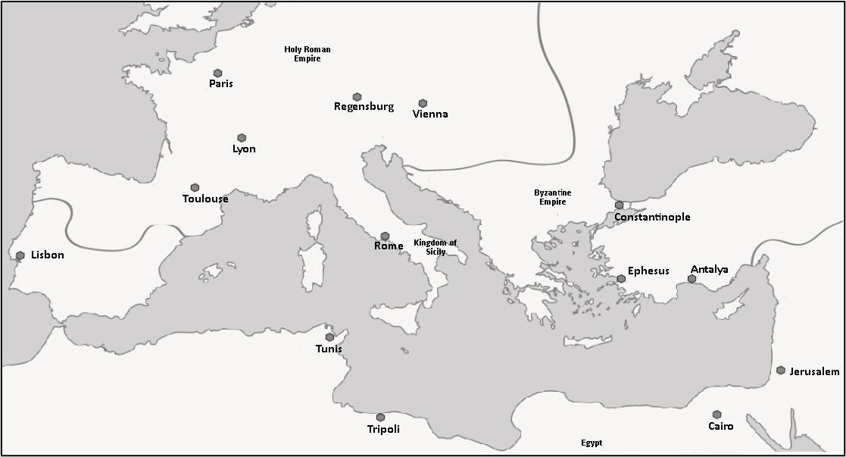
- The map shows which religions were dominant in which areas. Mark the areas with different colours.
- The Roman Catholic Church was dominant in the Kingdom of Sicily and the Holy Roman Empire.
- Cities where Islam was dominant included Tripoli, Cairo and Jerusalem.
- The Greek Orthodox Church was predominant in Ephesus and Antalya.
Note: The drawn lines represent approximate boundaries.
- Mark Jerusalem on the map.
Step 1 Applying Knowledge
- Discuss which of the following statements could be true or false. Write a T or F in the boxes and justify your opinion. Also take M1 and M2 into consideration.
It was not a problem for Christians that Jerusalem was not in the territory of the Roman Catholic Church, because this city was of no importance to them anyway.
When Christians made a pilgrimage to Jerusalem, it was very tiring and they often exposed themselves to great danger.
Located in the so-called Holy Land, Jerusalem was just as important to Muslims as it was to Christians. This could not lead to any conflicts.

Info-Box:
For a long time, Christians were able to make pilgrimages to Jerusalem in the Holy Land without hindrance. But when the Seljuks, a Turkish cavalry people from Central Asia, took power in Palestine (= Holy Land) in the 11th century, this had an impact on the Christian pilgrims. They were not always allowed to travel to Jerusalem - they were attacked and even killed by Muslims. Moreover, when the Byzantine Emperor lost a battle against the Seljuks, he called on Pope Urban II for help.
Step 3 Acquiring and Applying Knowledge
M3
Urban II (1088-1099): From the Speech at Council of Clermont, 1095:
[…] From […] Jerusalem and the city of Constantinople a horrible tale […] has been brought to our ears, namely, that a race from the kingdom of the Persians […] has invaded the lands of those Christians and […] has either entirely destroyed the churches of God or appropriated them for the rites of its own religion. They destroy the altars, […] Others they bind to a post and pierce with arrows. Others they […] attack them with naked swords, attempt to cut through the neck with a single blow. […]
On whom therefore is the labor […] of recovering this territory […] if not upon you? You, upon whom above other nations God has conferred remarkable glory in arms, great courage, bodily activity, and strength […]
Let none of your possessions detain you, […] since this land […] is too narrow for your large population; nor does it abound in wealth; and it furnishes scarcely food enough […]
Enter upon the road to the Holy Sepulchre; wrest that land from the wicked race […] That land which as the Scripture says "floweth with milk and honey," was given by God into the possession of the children of Israel. Jerusalem is the navel of the world; the land is fruitful above others, like another paradise of delights […] undertake this journey for the remission of your sins. […]
Dana C. Munro, "Urban and the Crusaders", Translations and Reprints from the Original Sources of European History, Vol 1:2, (Philadelphia: University of Pennsylvania, 1895), 5-8
Taken from: https://sourcebooks.fordham.edu/source/urban2-5vers.asp

Vocabulary
tale – Erzählung, hier: Nachricht
invade – eindringen
appropriate – beschlagnahmen
post – Pfosten
pierce – durchbohren
blow – Schlag, Hieb

labor – Arbeit, hier: Aufgabe
confer – verleihen
glory in arms – Waffenruhm
bodily activity – körperl. Gewandtheit

possession – Besitz
detain – aufhalten
narrow – eng
abound – im Überfluss vorhanden sein
furnish – versorgen
scarcely – kaum

Holy Sepulchre – Heiliges Grab
wrest - entreißen
wicked – niederträchtig, böse
remission – Vergebung
sin – Sünde
further:
________________________________________________________________________________________________

- Underline the parts from Pope Urban's speech that give you information about the headings mentioned under a, b, c. Use different colours for the headings. Mark the □ with the respective colour.
- □ Trigger for the speech of Pope Urban II
- □ Reasons for moving to Jerusalem
- □ Promises intended to make the journey to Jerusalem attractive
- Evaluate the Pope's speech. Justify your opinion. Your answers could start like this:
- The Pope made the right decision because…
- I don't like what the Pope says because…
- …
_________________________________________________________________________________________________________________________________________________________________________________________________________________________________________________________________________________________________________________________________________________________________________________________________________________________________________________________________________________________________________________________________________________________________________
Step 4 Acquiring and Applying Knowledge
Info-Box:
Thousands of Christians followed Pope Urban II's call and went to the Holy Land as soldiers. For many people in the 11th and 13th centuries these were armed pilgrimages in the sign of the cross.
M4
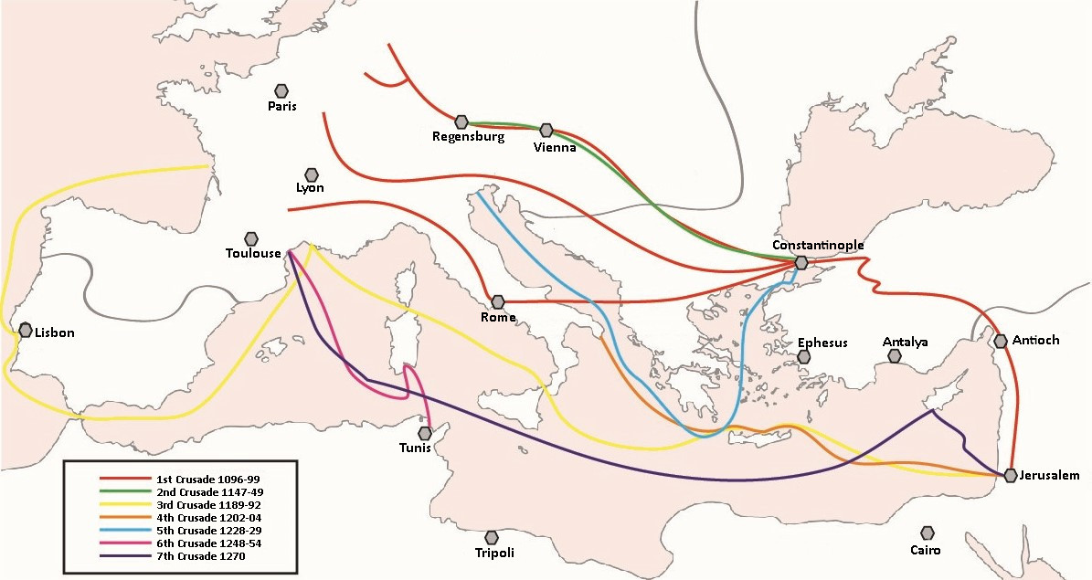
- Use the map to find out...
- how many Crusades there were between 1096 and 1270.
- where the Crusades ended.
- Discuss with a partner ...
- what difficulties people might have had on their way.
- whether the expectations of the crusaders could have been fulfilled.
M5
Vocabulary:
band – Truppe
avenge – rächen
pious – fromm
stroke – Hieb
slaughter – Massaker
foe >> enemy
mingle >> mix
infant – Kleinkind
suckling - Säugling
Soloman bar Samson, a Jewish chronicler - The Crusaders in Mainz, May 27, 1096:
[…] Emico a German noble, led a band of plundering German and French crusaders. Then the enemies of the Lord said to each other: 'look! They have opened up the gate for us. Now let us avenge the blood of 'the hanged one' [Jesus]
As soon as the enemy came into the courtyard they found some of the very pious there with our brilliant master, Isaac ben Moses. He stretched out his neck, and his head they cut off first. […] The enemy showered stones and arrows upon them, but they did not care to flee, and "with the stroke of the sword, and with slaughter, and destruction" the foe killed all of those whom they found there. […] The blood of the men mingled with their wives', the blood of the fathers with their children's, the blood of the brothers with the sisters, […] and the blood of infants and sucklings with their mothers'.

SOURCE: Jacob Marcus, The Jew in the Medieval World: A Sourcebook, 315-1791, (New York: JPS, 1938), 115-120.
Taken from: https://sourcebooks.fordham.edu/source/1096jews-mainz.asp

- Read M5 and find out what happened on the way to Jerusalem. To do this, fill out the table.
Who was attacked?
Reason for the attack
Approach / characteristics of the attack
- Evaluate the events from your point of view. Write adjectives and short comments in the thought bubbles.

Step 5 Acquiring and Applying Knowledge
- The conquest of Jerusalem is reported in M6 and M7. Discuss with a partner which report was written from a Muslim’s perspective (= A) and which from a crusader’s perspective (= B). Explain why.
M6
„ […] Jerusalem was taken from the north on the morning of July 15, 1099. The population was put to the sword by the Franks, who pillaged the area for a week. […] In the Al-Aqsa Mosque the Franks slaughtered more than 70,000 people, among them a large number of Imams and Muslim scholars, devout men who had left their homelands to live lives of religious seclusion in the Holy Place. The Franks stripped the Dome of the Rock of more than forty silver candelabra and more than twenty gold ones, and a great deal more booty. Refugees reached Baghdad and told the Caliph’s ministers a story that wrung their hearts and brought tears to their eyes. They begged for help, weeping so that their hearers wept with them as they described the sufferings of the Muslims in that Holy City: the men killed, the women and children taken prisoner, the homes pillaged.”
Source: Excerpt from Ibn al-Athir’s “The Complete History,” written in 1231.
Vocabulary:
Franks – Franken, hier sind die Kreuzfahrer gemeint
pillage – plündern
slaughter – abschlachten
devout – fromm
seclusion – Abgeschiedenheit
strip – ausräumen
candelabra – Armleuchter
booty – Beute
weep – weinen

This source was written from □ A □ B
I can see that because _____________________________________________________________
________________________________________________________________________________________________________________________________________________________________________________________________________________________________________________
M7
Vocabulary:
take possession – Besitz ergreifen
merciful – gnädig, barmherzig
bridle rein – Zügel
splendid – großartig
petition – erbitten
[…] Finally, our men took possession of the walls and towers, and wonderful sights were to be seen. Some of our men (and this was more merciful) cut off the heads of their enemies; others shot them with arrows, so that they fell from the towers. It was necessary to pick one's way over the bodies of men and horses. In the Temple of Solomon, men rode in blood up to their knees and bridle reins. Indeed, it was a just and splendid judgment of God that this place should be filled with the blood of the unbelievers, since it had suffered so long from their blasphemies. Some of the enemy took refuge in the Tower of David, and, petitioning Count Raymond for protection, surrendered the Tower into his hands. […]
Source: Raymond d'Aguiliers, “The Siege and Capture of Jerusalem,” exact date unknown.

This source was written from □ A □ B
I can see that because _____________________________________________________________
________________________________________________________________________________________________________________________________________________________________________________________________________________________________________________
- Discuss which author (A or B) you believe more and justify your opinion.
- Imagine you could meet both authors. Think about what interests you about the reports and what questions you want to ask them.
__________________________________________________________________________________________________________________________________________________________________________________________________________________________________________________________________________________________________________________________________________________________________________________________________________________________________________________________________________________________
Step 6 Acquiring Knowledge
There are modern English words that came from old Arab languages.
- Discuss with a partner and try to complete the grid with the missing English words.
Arab | English | Arab | English
al-jabr |  | qahwa
kēme |  | līmūn
märzäban |  | al-kuhl
qandī |  | makhāzin
matrah |  | sukkar
qaīrawān |  | soffa

- Look at the words and describe which areas of people's lives were influenced by the Arabs and how this might have affected them.
- Find out in which other areas of life Europeans learned from the Arabs. Read the texts in the boxes and match the correct umbrella terms. Choose six different colours for the umbrella terms and fill in the matching info boxes in the same color.
M8
New spices like pepper, nutmeg, cloves, caraway, cinnamon or saffron are used for cooking.

You calculate with letters. This is called "algebra".
There are new symbols: 0, 1, 2, 3, 4, 5, 6, 7, 8, 9. Any number can now be written with these.

Goods and luxuries are exchanged: pearls, precious stones, cotton, dyes (e.g., ultramarine).
Carpets, curtains, sofas and stained glass windows can be found in the houses.
An anatomical drawing of the human body structure was created in the 15th century. An Arab doctor labels the skeleton with information about injuries and treatment options.

Knife and fork are used for eating.

From the 13th century onwards, Islamic scientists calculate the planetary orbits with a so-called ‘astrolabe’. With this you could determine the exact time of day.
Medicines made from herbal substances are used for healing and difficult operations are performed.
Ibn al-Nafis was able to demonstrate the circulation of blood in the human body.

Chess becomes a popular game.

Mathematics
Food
Everyday Life, Living and Leisure
Medicine

Science
Trade

