Pickleball
Kompetenzerwartung | Lernbereich 2:  Die Schülerinnen und Schüler ...  - Lernen neue Spielregeln kennen, bewerten die Auswirkungen von Verstößen und schätzen Fairplay.  - respektieren die Bedürfnisse ihrer Mitschülerinnen und Mitschüler auch unter Wettbewerbsbedingungen.  Lernbereich 4.3: Spielen und Wetteifern  Die Schülerinnen und Schüler…  - erweitern systematisch ihre Erfahrungen in den Rückschlagspielen und alternativen Spielen und sammeln so auch weitere Anregungen und Fertigkeiten für ihre Freizeit.  - würdigen den Fairplay-Gedanken als übergeordnetes Ziel.
zeitlicher Rahmen | mindestens eine Doppelstunde
Ressourcen | Turnhalle: ein bis zwei Hallendrittel - Platzbedarf wie bei Badminton
Durchführung | Einführung, Aufwärmen, Üben, Regelkunde, Spielen 1:1 / 2:2, Feedback einholen
Anregungen und Tipps | Sport mit großem Aufforderungscharakter - für erste Erfahrungen Kontakt zum nächstgelegenen Pickleball Verein aufnehmen. Häufig können dort für die ersten Stunden Materialien entliehen werden.
Literatur zum Thema | Hall, s. Danitaw. (2023). Master the Basics of Pickleball Fast: Learn the Essential Skills and Strategies to Quickly Master the Thrilling Sport of Pickleball.  Johns, Tyson. (2022). Pickleball for Beginners: Learn How to Play Pickleball with Pickleball Basics, Rules, Techniques, and Strategies to Master the Game. Publishing Forte.
Materialien | Picklebälle, Pickleball Schläger (Paddles), Netze (Badminton)
Autor | David Matheisl, Staatliche Realschule Hilpoltstein

Stundenverlauf: Pickleball
 | Struktur | Erläuterung
Stundenverlauf | Einstieg und Aufwärmen | Aufbau der Netze. Sitzkreis (show paddle and ball)  L: Welcome to today’s lesson. Do you have an idea which sport this racket and this ball are for?  (let students guess)  L: It is for Pickleball. Do you know where it comes from?  (The sport comes from the USA. It has become a big trend.)  L: Any Ideas how many people play it there? (40 mio. / One in eight persons.)
 | Erarbeitung I | Teacher demonstrates how to hold the paddle and how to hit the ball correctly.  Warm up (students line up next to each other)  Every player gets a paddle and  - bounces the ball.  - and they also run to the opposite wall of the gymnasium.  - without losing the ball.  - as fast as they can.  - bounce with their weaker arm.
 | Übungsphase  mit Korrektur | Practice 1:1 (together, short distance, without net)  Student A throws ball / B hits it back so A can catch. (Taking turns after a few minutes).  Practice 1:1 (using net)  Try to play as often as possible.  Hinweis:  - gemeinschaftliche Korrektur der gröbsten Fehler. Evtl. erneute Technik-Demonstration durch die Lehrkraft  - Individuelle Fehlerkorrektur.
 | Erarbeitung II | Explain simple rules or let students explain (see instructions and materials on page 6)  1. Serving:  • The serve must be made underhand, with the paddle contacting the ball below the server’s waist.  • The serve is made diagonally cross-court and must clear the non-volley zone.  • The serve must land in the opposite diagonal court, beyond the non-volley zone line.  • The server must keep both feet behind the baseline during the serve.  2. Scoring:  • Only the serving team can score points.  • Games are typically played to 11 points, and a team must win by at least 2 points.  3. Double Bounce Rule:  • Each team must let the ball bounce once on their side before volleys are allowed.  • After the initial two bounces, players can either volley the ball (hit it in the air) or play it off a bounce.  4. Non-Volley Zone (The Kitchen):  • Players cannot volley the ball while standing within the non-volley zone or on its lines.  • A player may step into the non-volley zone to play a ball that has bounced but must exit before playing a volley.  5. Faults:  • A fault occurs when the ball is hit out of bounds, does not clear the net, is volleyed from within the non-volley zone, or if a player violates the double bounce rule.  • A fault by the serving team results in the serve being passed to the opposing team (side out).  6. Serving Rotation (Doubles):  • In doubles, each player on the serving team gets a chance to serve before the serve goes to the other team.  • The server’s partner should be positioned behind the baseline during the serve.  • The first serving team of the game only has one player serve to start; afterward, both players get a chance to serve.  7. Game Conduct  1. Sportsmanship: Players should exhibit good sportsmanship, including honesty in calling lines and respect for opponents and partners.  2. Line Calls: Balls landing on the lines are considered in, except the non-volley zone line during a serve.  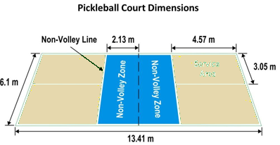  Service  Area
 | Spiel | 1:1  2:2
 | Sicherung und Abrundung | Sitzkreis:  Feedback, Geräteabbau.

A) Getting Started: Materials

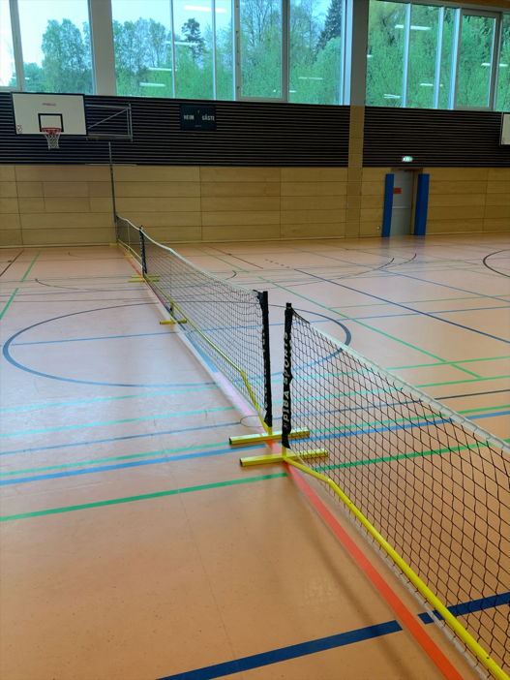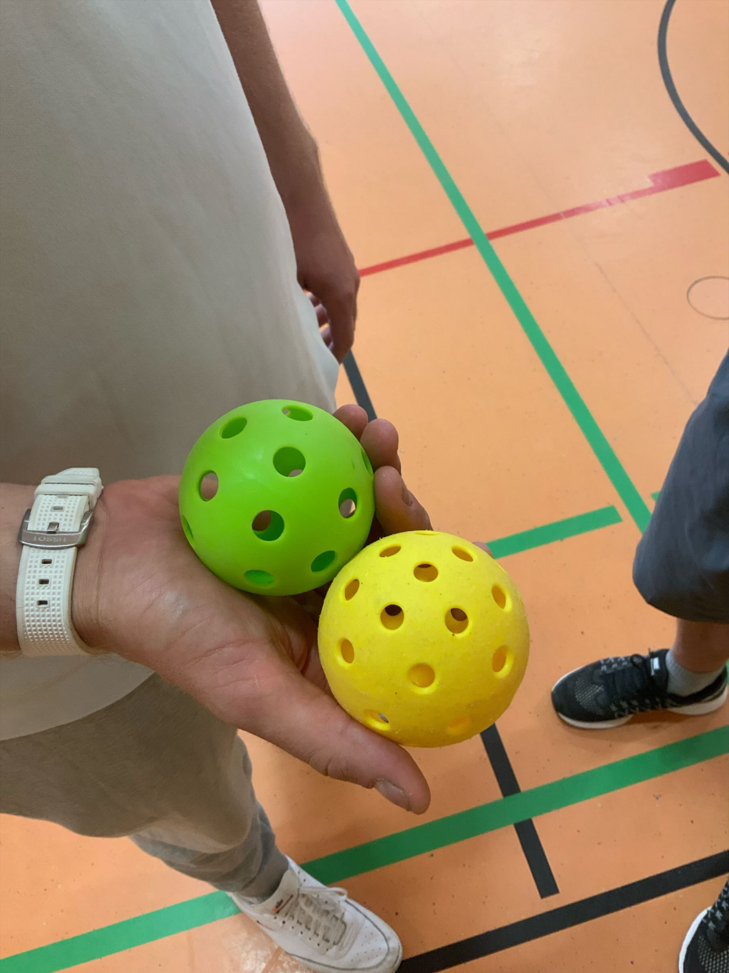
Badminton nets divide the court. Pickleballs: green = indoor / yellow = outdoor

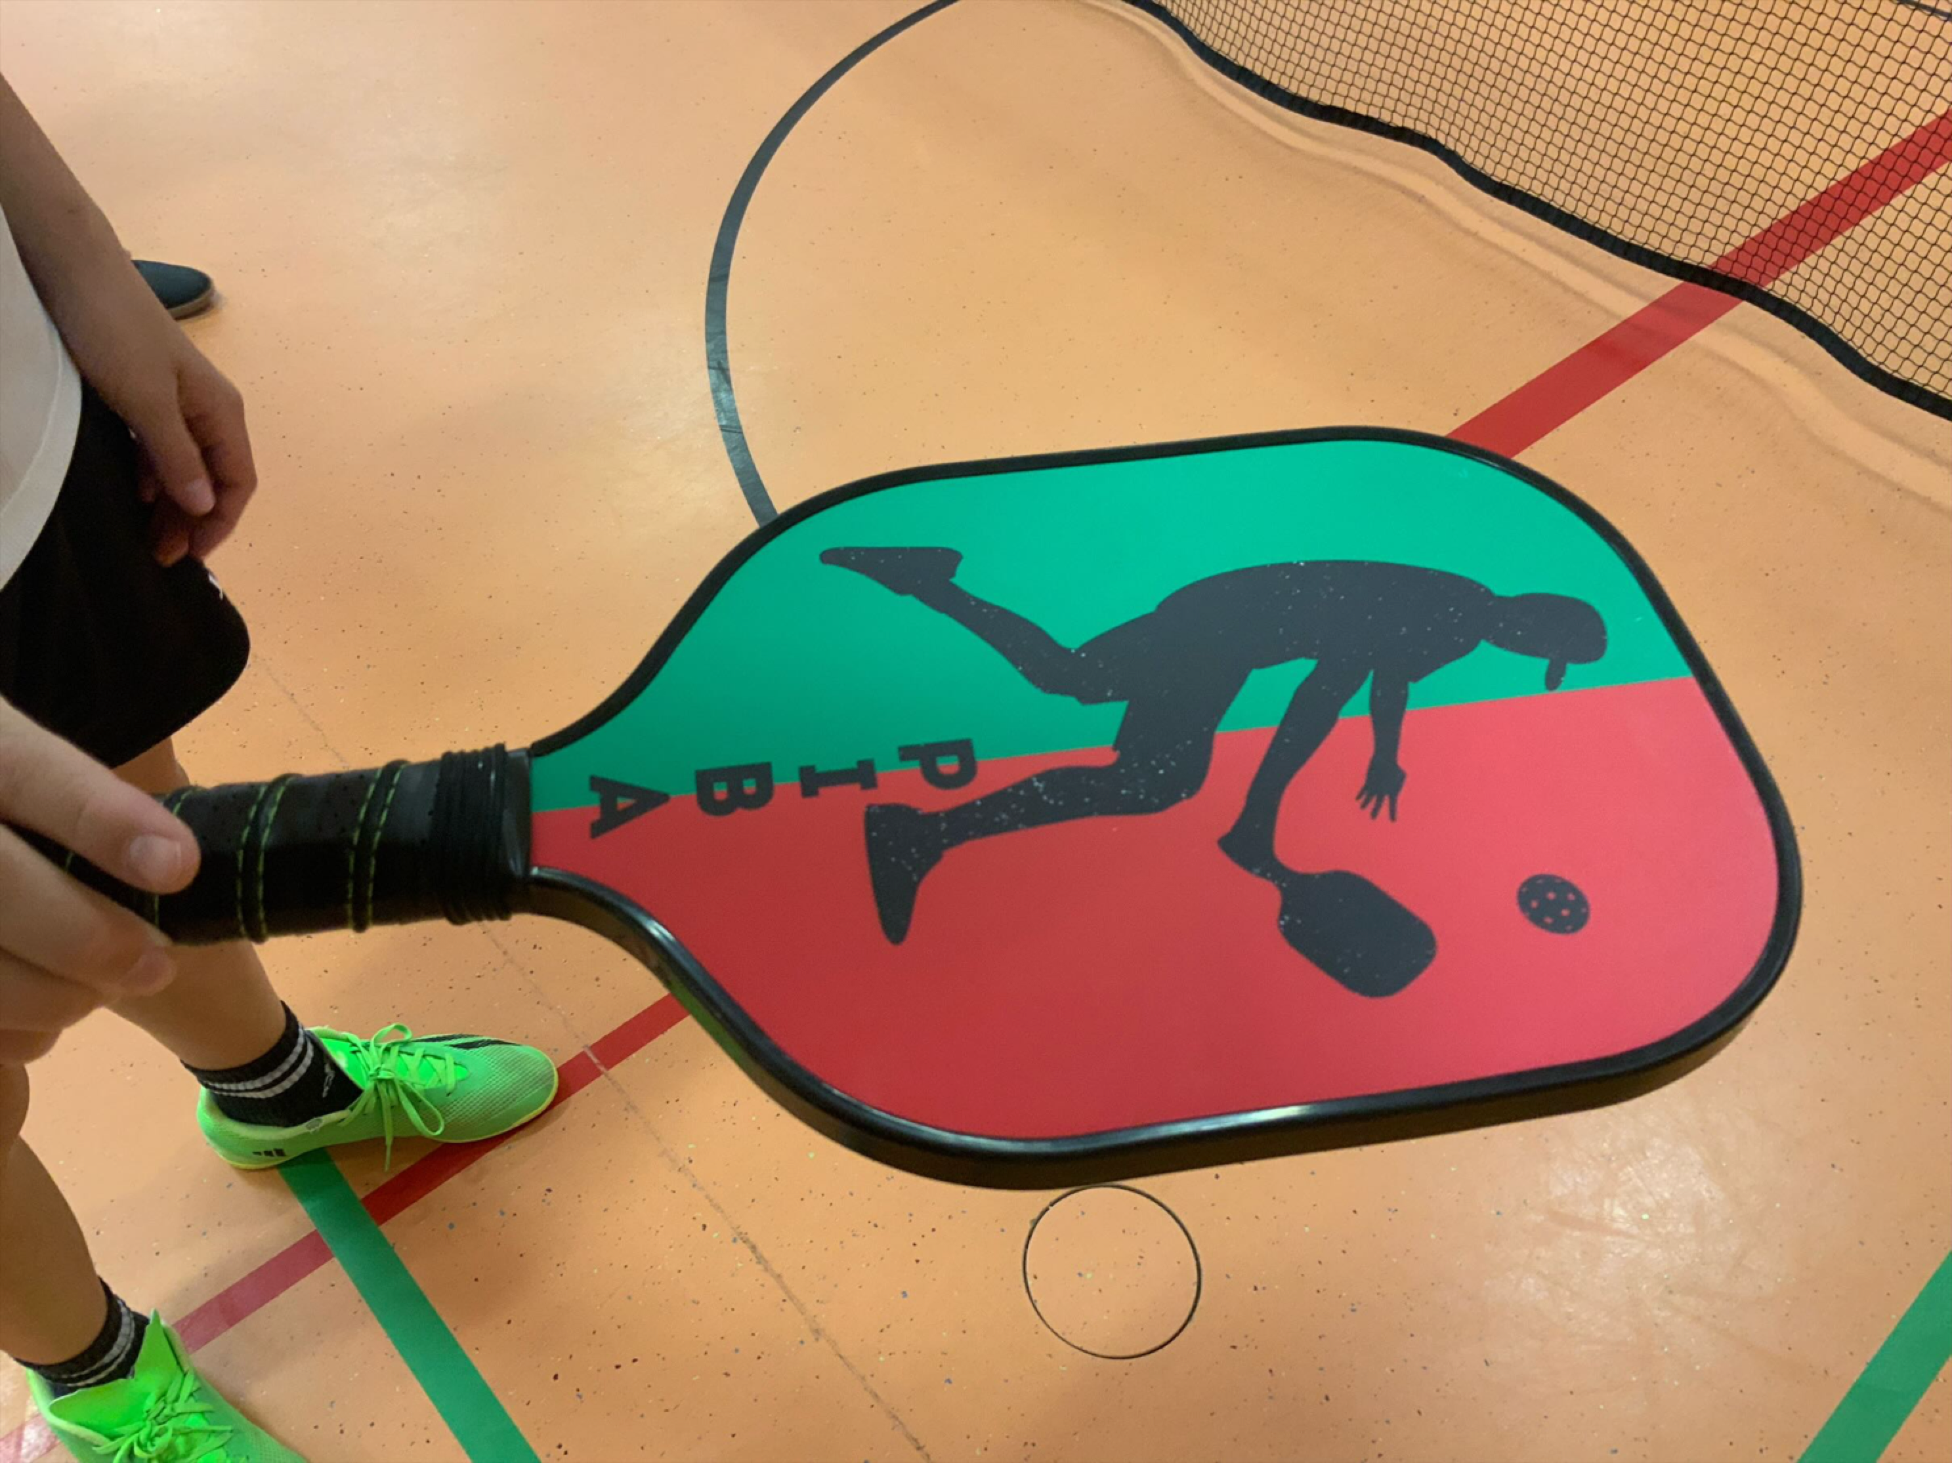
A Pickleball paddle.

Basic Rules of Pickleball
Can be distributed among the learners in small groups. After a short preparation period, they can explain and demonstrate their rule
1. Serving:
The serve must be made underhand, with the paddle contacting the ball below the server’s waist.
The serve is made diagonally cross-court and must clear the non-volley zone.
The serve must land in the opposite diagonal court, beyond the non-volley zone line.
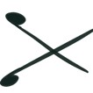
The server must keep both feet behind the baseline during the serve.

2. Scoring:
Only the serving team can score points.

Games are typically played to 11 points, and a team must win by at least 2 points.

3. Double Bounce Rule:
Each team must let the ball bounce once on their side before volleys are allowed.
After the initial two bounces, players can either volley the ball (hit it in the air) or play it off a bounce.

4. Non-Volley Zone (The Kitchen):
Players cannot volley the ball while standing within the non-volley zone or on its lines.
A player may step into the non-volley zone to play a ball that has bounced but must exit before playing a volley.

5. Faults:
A fault occurs when the ball is hit out of bounds, does not clear the net, is volleyed from within the non-volley zone, or if a player violates the double bounce rule.
A fault by the serving team results in the serve being passed to the opposing team (side out).

6. Serving Rotation (Doubles):

In doubles, each player on the serving team gets a chance to serve before the serve goes to the other team.

The server’s partner should be positioned behind the baseline during the serve.

The first serving team of the game only has one player serve to start; afterward, both players get a chance to serve.

C) Useful Vocabulary:
Basic Vocabulary for Pickleball
1. Ball: The plastic ball with holes, similar to a wiffle / floor ball, used in the game.
2. Baseline: The line at the back of each side of the court.
3. Centerline: The line dividing the left and right service courts.
4. Court: The playing area for pickleball, which is 6.1 meters wide (20 feet) and 13.41 meters long (44 feet).
5. Double Bounce Rule: The rule that requires each team to let the ball bounce once on their side before they can volley it.
6. Fault: A mistake or rule violation that ends the rally and results in a point for the opponent or a change of serve.
7. Game: A match in pickleball, usually played to 11 points, and a team must win by at least 2 points.
8. Net: The net divides the court into two halves. It is 91.44 centimeters high (36 inches) at the sidelines and 86.36 centimeters high (34 inches) in the middle.
9. Non-Volley Zone (Kitchen): The 2.13-meter area (7 feet) on either side of the net where players cannot volley the ball (hit it out of the air).
10. Paddle: The equipment used to hit the ball. It is solid and can be made of wood, composite, or other materials.
11. Rally: A sequence of back-and-forth hits between players or teams during a point.
12. Serve: The action of starting a point by hitting the ball underhand into the opponent’s service court.
13. Service Court: The area where the serve must land. Each side of the court has left and right service courts.
14. Sideline: The lines along the sides of the court.
15. Side Out: When the serving team loses the serve, and the other team gets to serve.
16. Volley: Hitting the ball before it bounces on the ground.

Quellen:

Literatur:

Hall, s. Danitaw. (2023). Master the Basics of Pickleball Fast: Learn the Essential Skills and Strategies to Quickly Master the Thrilling Sport of Pickleball.

Johns, Tyson. (2022). Pickleball for Beginners: Learn How to Play Pickleball with Pickleball Basics, Rules, Techniques, and Strategies to Master the Game. Publishing Forte.

Fachliche Information für Lehrende und weiterführende Links:
https://deutscher-pickleball-verband.de
https://usapickleball.org
https://www.ppatour.com

